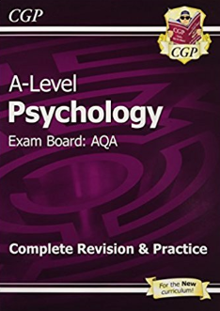
Psychology Reading list
- Advised for those who are concerned about the jump from GCSE to A level. This book does the basics well, but compromises on depth
A-Level Psychology: AQA Year 1 & 2 Complete Revision & Practice (CGP A-Level Psychology)
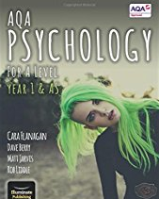
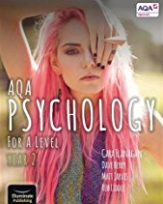
- Unashamedly produced to appeal to students, this book (and it’s year 2 counterpart) mix trendy graphics and snapshot hints with some detail and reasonable evaluation. Can make you cringe in places, and is sometimes lacking in clarity. Has some very good model answers and marked examples
AQA Psychology for A Level Year 1 & AS - Student Book - 23 Mar 2015 by Cara Flanagan and Dave Berry
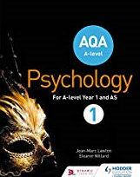
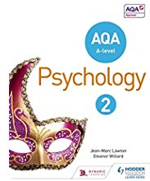
- A standard text book that has more depth than the one above, but lacks model and marked examples. Clear in description but lacks the student friendliness we are becoming accustomed to in psychology textbooks. Standard but a bit ‘dry’ perhaps? Two volumes for year 1 and year 2
AQA A-level Psychology Book 1 - 24 Apr 2015 by Jean-Marc Lawton and Eleanor Willard
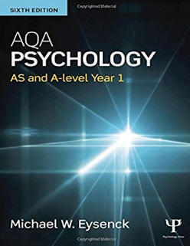
- More than what you need just for the A level, and would work well as a first year degree reference. There is a lot to get your teeth into, with plenty of depth and analysis. Teachers like this book for preparation of the course, but can be a challenging read if you are looking for a simple and quick explanation into something. There are attempts to make it accessible with some pictures and bullet-pointed evaluation, but no model or marked examples for guidance. Do date, there doesn’t appear to be a year 2 version.
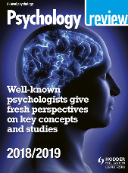
AQA Psychology: AS and A-level Year 1 – 30 Apr 2015 by Michael Eysenck

There are revision and work books by the same authors, but make sure any resource you get is AQA and published after 2015. Also consider the 4 issues a year magazine targeted at A level psychology students called ‘Psychology review’. There are copies in the library in the journal section

