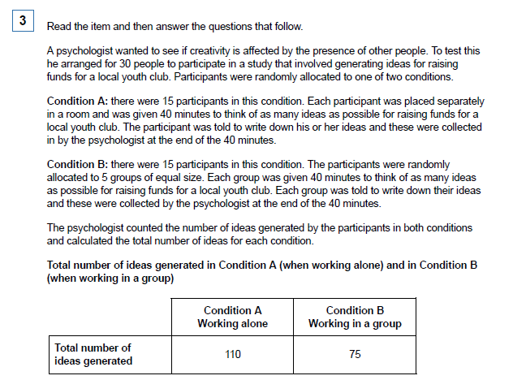

a) Identify the experimental design used in this study and outline one advantage of this experimental design. (3)

(b) Describe one other experimental design that researchers use in psychology. (2)

(c) Apart from using random allocation, suggest one way in which the psychologist might have improved this study by controlling for the effects of extraneous variables. Justify your answer. (2)

(d) Write a suitable hypothesis for this study. (2)

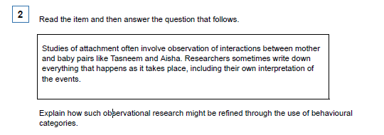
(2 marks)

Q1

A psychologist carried out a research study to investigate the effects of institutional care. To do this, she constructed a questionnaire to use with 100 adults who had spent some time in an institution when they were children.

She also carried out interviews with ten of the adults.

(a) For this study, explain one advantage of collecting information using a questionnaire. (3)

(b) In this study, the psychologist collected some qualitative data. Explain what is meant by
qualitative data. (2)

(c) Write one suitable question that could be used in the interviews to produce qualitative data. (2)

(d) Identify two ethical issues that the psychologist would need to consider in this research.
Explain how the psychologist could deal with one of these issues. (5)

Ethical Issue 1........................................................................................................................................

Ethical Issue 2........................................................................................................................................

How the psychologist could deal with one of these issues …………………………………………………….…
………………………………………………………………………………………………………………………………………………………………………………………………………………………………………………………………………………………………………………………………………………………………………………………………………………………………………………………………………………………………………………………………………………………………………………………………………………

Q5
A maths teacher wondered whether there was a relationship between mathematical ability and musical ability. She decided to test this out on the GCSE students in the school. From 210 students, she randomly selected 10 and gave each of them two tests. She used part of a GCSE exam paper to test their mathematical ability. The higher the mark, the better the mathematical ability. She could not find a musical ability test so she devised her own. She asked each student to sing a song of their choice. She then rated their performance on a scale of 1–10, where 1 is completely tuneless and 10 is in perfect tune.

(a) Suggest a suitable non-directional hypothesis for this study. (3)

(b) Why might the measure of musical ability used by the teacher lack validity? (3)

(c) Explain how the teacher could have checked the reliability of the mathematical ability test. (3)

(d) Explain why the teacher chose to use a random sample in this study. (2)

Q8

A psychologist studying the primacy effect in impression formation conducted the following experiment.

Each participant was taken to the same room where they listened to a description of a person called ’Alex’. The participants were randomly allocated to one of two groups in the experiment. The psychologist gave each participant the same information about ’Alex’, but the order of the information varied depending on the group.

Group A Five positive points about Alex’s personality were followed by five negative points.

Group B Five negative points about Alex’s personality were followed by five positive points.

After listening to the passage, each participant was asked to state whether they thought ’Alex’ was a friendly person or not. The psychologist recorded how many participants in each group stated that Alex was ’friendly’.

- Identify the type of experiment that was conducted. (1)

- Briefly explain one advantage of the type of experiment that you have identified in your answer to part (a). (2)

- Identify the independent variable and the dependent variable in this experiment. (2)

- Identify the experimental design used in this study. (1) (Total 6 marks)

Q22

A psychologist carried out an experiment using an independent groups design. The psychologist wished to investigate the effectiveness of a strategy for memory improvement. In one condition, participants were taught a memory improvement strategy. In the other condition, participants were not taught this memory improvement strategy. All participants were asked to memorise 10 pictures of familiar objects. For example, the first was a doll, the second was an apple. All participants were then given 50 pictures each, and asked to select the original 10. The psychologist did a pilot study before carrying out the experiment. The results of the experiment are shown in the table below.

(a) Write a directional hypothesis for this experiment. (2)

(b) Explain what is meant by an independent groups design. (1)

(c) Explain one strength and one limitation of using an independent groups design. (4)

Strength

Limitation

(d) Explain why the psychologist did a pilot study. (3)

Q27
It is thought that colours might affect our performance when carrying out certain tasks. Research in this area has been inconclusive. Some studies have shown that red improves performance but others have found the opposite. It could be that these contradictory results have arisen because red is beneficial only for certain kinds of mental processing. Some psychologists tested this hypothesis in a series of independent-groups design experiments using students at a Canadian university.

The experiments involved computer tasks, with either a red, blue or neutral background appearing on the monitor. The researchers found that participants were better at a word-recall task and a spell-checking task when the screen background was red rather than blue or neutral. However, participants thought of more creative ideas when the screen was blue rather than red or neutral.

The researchers concluded that red is beneficial for tasks that require attention to detail whereas blue aids creativity.

(a) What were the researchers’ aims in this study? (2)

Imagine that you are writing up the report for this series of experiments.

(b) What is the purpose of the introduction section of a report? (2)

A psychological report also contains a discussion section. Researchers are expected to consider their findings critically and discuss issues such as validity.

(c) What is meant by validity? (1)

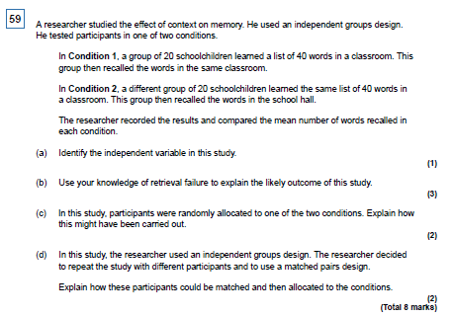

Q 60

Dave, a middle-aged male researcher, approached an adult in a busy street. He asked the adult for directions to the train station. He repeated this with 29 other adults.

Each of the 30 adults was then approached by a second researcher, called Sam, who showed each of them 10 photographs of different middle-aged men, including a photograph of Dave. Sam asked the 30 adults to choose the photograph of the person who had asked them for directions to the train station.

Sam estimated the age of each of the 30 adults and recorded whether each one had correctly
chosen the photograph of Dave.

(a) Identify one aim of this experiment. (2)

(b) Suggest one reason why the researchers decided to use a field experiment rather than
a laboratory experiment. (2)

(c) Name the sampling technique used in this experiment. Evaluate the choice of this sampling
technique in this experiment. (4)

d) Identify one possible extraneous variable in this experiment. Explain how this extraneous
variable could have affected the results of this experiment. (4)

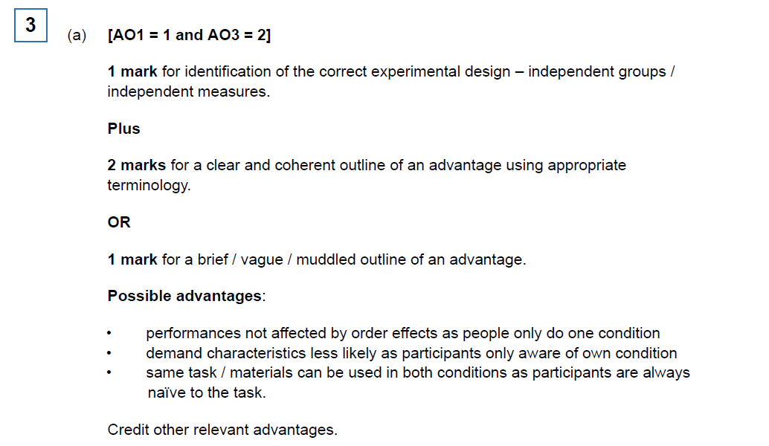
Mark Scheme

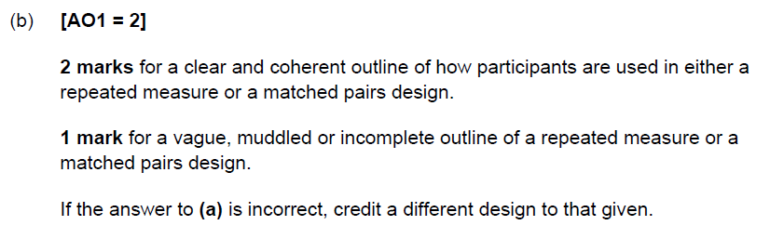
c) [AO3 = 2]
1 mark for an appropriate and plausible suggestion. Plus 1 mark for an appropriate justification.

Likely suggestions:
• testing all participants in the same room
• making sure that all participants hear the same instructions
• ensuring that all participants are tested by the same researcher.
Credit other relevant suggestions.

(d) [AO2 = 3]

3 marks for an appropriate non-directional (or directional) operationalised
hypothesis: ‘There is a difference in the number of ideas generated when participants
work alone and when they work in groups.’

2 marks for a statement with both conditions of the IV and DV that lacks the clarity or
has only one variable operationalised.

1 mark for a muddled statement with both conditions of the IV and DV where neither
variable is operationalised.

0 marks for expressions of aim / questions / correlational hypotheses or statements
with only one condition.

Full credit can be awarded for a hypothesis expressed in a null form.

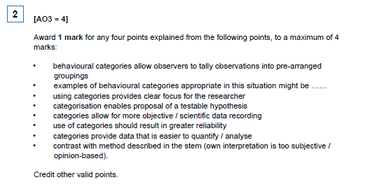
Q6

AO1 = 2
1 mark for stating that overt observation is where the observer is clearly visible (not hidden
from view). Plus 1 mark for explanation – people being observed know that they are being observed.

Q1
(a) AO3 = 3
Advantages of using a questionnaire in this study could include that data from the hundred
adults could be collected relatively quickly because the researcher would not need to be
present when the questionnaires were completed; participants might be more willing to
answer honestly because they would feel more anonymous; there might be a reduction in
investigator effects because the researcher's reactions would not be visible. The advantage
must be one that could be applied to this study.
1 mark for a slightly muddled or very brief outline of an advantage. Further marks for
accurate elaboration.

(b) AO3 = 2
Qualitative is non-numerical and uses words to give a full description of what people think
or feel.
1 mark for a very brief or slightly muddled answer eg qualitative data uses words.
2nd mark for accurate elaboration eg by comparison or by using an example.

(c) AO3 = 2
One mark for a question which would produce qualitative data but is not appropriate eg
"How are you feeling?"
Two marks for an appropriate question eg "Tell me what it was like in the institution"
(Full marks can be awarded if it is not in the form of a question)
0 marks for a question that would not produce qualitative data.

(d) AO3 = 1 + 1 + 3
There are no ethical issues named in the specification, so any potentially relevant issues should be credited.

Likely ethical issues include informed consent, right to withdraw, protection from harm, confidentiality, respect or the need for debriefing in this particular case.

Other issues such as deception (deliberate or by omission) can be credited as they could
apply in this research.
One mark each for identification of a relevant ethical issue.
One mark for a brief mention of how the issue could be dealt with.
Two further marks for elaboration appropriate to this research.

There is a depth / breadth trade-off. Candidates may explain one way of dealing with the
issue in some depth, or mention several ways (of dealing with one issue) more briefly.

Ethical issue one eg, right to withdraw (1 mark); ethical issue two eg confidentiality
(1 mark); Don't identify the participants (1 mark). Don't use photographs or names in
published research. Names of people and / or places should be changed (2 further marks).

Q5

- AO2 / AO3 = 3

A suitable non-directional hypothesis would be ‘There is a correlation (relationship) between pupils’ scores on a test of mathematical ability and pupils’ scores on a test of
musical ability’.

3 marks for a fully operationalised non-directional hypothesis.
2 marks for non-directional hypothesis that identifies both variables but does not
operationalise them.
1 mark for non-directional hypothesis where the variables are not identified.
No marks for a null or directional hypothesis or one referring to association or difference.

(b) AO2 / AO3 = 3
The main issue is that the teacher has made up her own test:
• This involved subjective judgement on the part of the teacher who rates the students’
musical ability. Her judgement may not reflect real differences in musical ability and is
likely to differ from other people’s judgement and / or any absolute criteria for
tunefulness.

• Lack of reliability in rating musical ability would compromise the validity of the
measure.

• As the students can choose the song they will sing, the rating of ability could reflect
the teacher liking / dislike of the song rather than the student’s ability.

• The rating may be invalid as the students selected songs which varied in difficulty so
the tunefulness reflected the difficulty of the song not the students’ ability.

• Operationalising musical ability as tuneful singing is a very narrow measure.
Someone can have musical ability such as playing an instrument which would not be
reflected by this measure.

1 mark for identifying an appropriate reason.

2 further marks for elaboration, explanation of why it is a problem, how it might affect the
result or for further reason(s).

Note that 3 marks can be awarded for one reason elaborated or more than one reason in
less detail.

(c) AO2 / AO3 = 3
In the case of the maths test candidates could refer to split half or test retest as methods of
checking reliability. They could also refer to checking the reliability of scoring by using two
separate markers for the test and comparing the scores. Credit any other appropriate
suggestion.

1 mark for identifying an appropriate method or a brief explanation eg ‘repeat the maths test’.
2 further marks for appropriate elaboration.

(d) AO2 / AO3 = 2
The teacher chose to use a random sample because it would probably be more
representative of the whole GCSE group than if she had used an opportunity or volunteer
sample. Candidates could also say that she had ready access to her target population
making it convenient for her to select a random sample.
No credit for definition of a random sample.
1 mark for a brief or muddled reason (it is not biased).
2 marks for a reason that clearly points to an advantage of random sampling. This could be
achieved through a comparison with another method (it is less likely to be biased than a
volunteer sample).

Q8

(a) [AO3 = 1]
One mark for identification of laboratory experiment.

(b) [AO3 = 2]
Up to 2 marks for an explanation of an advantage of a laboratory experiment. Possible answer: As the research takes part in a controlled environment, the researcher can eliminate the possible effect of extraneous variables. Answers are likely to focus on advantages based on increased control of variables /
increased causality / replicability.

The advantage can be credited if it corresponds with the answer in 6.

(c) [AO3 = 2]
Independent variable: whether the list of points was positive then negative or negative then positive / the order of the points / information. Answer must imply that there is more than one condition.

Dependent variable: whether (or not) they said Alex was ‘friendly’ / the number of participants who said Alex was ‘friendly’ / number of ‘friendly’ responses.

No credit for 'level of friendliness'.

• Award both marks for correct IV and DV that are not labelled but are in the order of the quesiton.
• Award 1 mark for correct IV and DV that are not labelled and are not in the order of the question ie DV then IV.
• No credit for either IV or DV alone (if not labelled).

(d) [AO3 = 1]
One mark for identifying independent measures / groups / samples / unrelated

Q22

a) AO3 = 2
0 marks for a non-directional or correlational hypothesis.
The DV in this experiment is number of pictures correctly identified. Hypotheses where the
DV is incorrect (eg number of participants who identified 10 pictures) = 0 marks.
1 mark if not fully operationalised, eg Participants who used the memory improvement
strategy did better.
2 marks Participants who use a memory improvement strategy will correctly identify more
pictures / objects than participants who do not use a memory improvement strategy.

(b) AO3 = 1
In an independent groups design a different group of participants is used in each condition.
1 mark = Different participants / people in each condition / group
Different / separate groups/ Random allocation to groups / conditions.
0 marks = Different / separate conditions /Independent participants / people /Different experiments.
(
c) AO3 = 2 + 2
Strength
The participants are naÏve because they take part in only one condition, so are less likely to
show demand characteristics. There are no order effects such as practice or fatigue
because participants take part in one condition.
Limitation
Individual variation, because there are different participants in each condition. More
participants are needed than if a repeated measures design was used.
In each case 1 mark for very brief or slightly muddled strength or limitation, 2nd mark for
appropriate elaboration of explanation.
0 marks for simply stating there are different participants in each condition.
AO3 = 3
d) A pilot study is used to check aspects of the research such as whether participants understand standardised instructions, whether timings are adequate etc. It allows the researcher to try out the study with a few participants so that adjustments can be made before the main study, so saving time and money.

1 mark for a very brief explanation. Further marks for appropriate elaboration or
identification of other reasons. Eg

To check it works. 1 mark
To check the standardised instructions are clear. 2 marks
To check the standardised instructions are clear enough for the participants to understand
what they are required to do in the experiment. 3 marks

This question requires an explanation of why a pilot study was used, so a description of what a pilot study is (small scale study carried out before the main research) is not creditworthy on its own. Candidates do not have to refer to a specific aspect of this experiment. However, to gain full marks the answer must be relevant, so reference to checking sound levels for example would not be relevant.

Q59

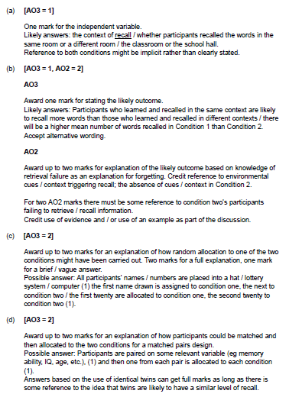

Q27
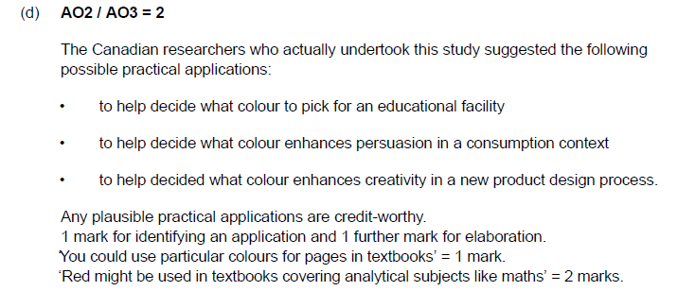
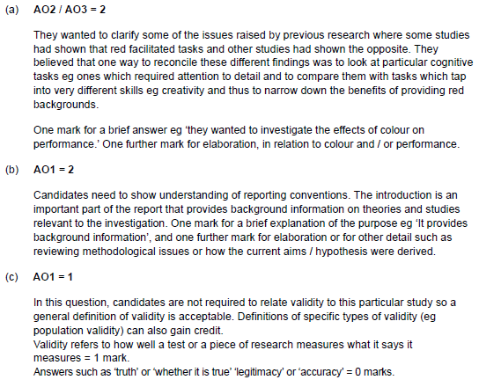

Q60

