Recap prep: Sampling
Using your pack fill in the following sampling grid and then attempt the activities to go with it.
Sampling
Define population (with example)

Define Target population (with example)

Define Sample (with example)

Define Sampling bias

Type of sampling and how the sample is gathered | Weaknesses | Strengths
Random

Opportunity

Volunteer

Systematic

Stratified

Now attempt these questions using your new sampling knowledge.
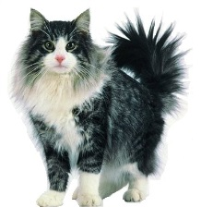
I have been asked by a pet food company to research which brand of cat food is most popular with cat owners. They plan to launch a competing product, similar in packaging, texture and smell, to the most popular brand, but they will make it 3p cheaper in an attempt to gain a large share of the cat food market. I stand on the corner of George Street in Hove, with a clipboard, between the hours of 9.30am and 5pm, Monday to Friday for a week. I ask each person I approach if they are a cat owner. If they say yes, and agree to talk to me, I ask them what cat food they buy for their cat and record the result. At the end of the week, from my research I conclude that Kit-e-kat is the most popular brand of cat food. I go back to my boss with the results of my survey. Consequently, the company markets a product that looks, tastes and smells like kit-e-kat. They distribute it to cat food retailers nationwide BUT Kat-e-Kit flops, The company go bust, I get fired
Where did it all go wrong? Explain where it might have all gone wrong using the terms population, target population, sample and sample bias. Don’t forget to link to the scenario (4 marks)

Identify the type of sampling in the following examples and justify your answer
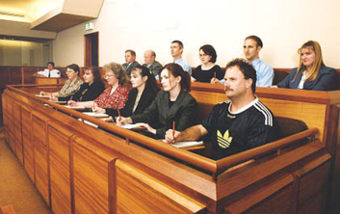
1.) Members of a jury?

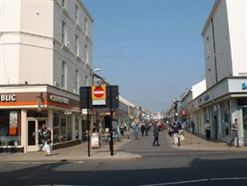
2.) The kit-e-kat market research above?

3.) A firm has been told their workers are de-motivated and demoralised. The union says they need to find out why as is affecting their worker well-being. They don’t want to ask all 1,000 workers so decide a sample of 20 will do, they decide then to ask every 50th employee how they feel.

4.) The head of the Psychology department wants to runs some research on BHASVIC Psychology students but hasn’t got the time or resources to do it on all 600 students. There are 40% males and 60% females so when randomly selecting the students he collects 40 males and 60 females.

