Student Information Pack
Unit 1: Social Influence

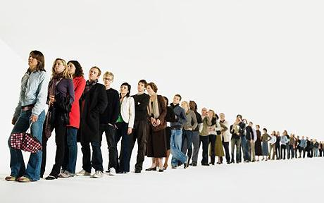
Conformity

Conformity refers to how an individual or small group change their behaviour and/or attitudes as a result of the influence of a larger group, where there is no direct request for them to do so.

Explanations of why people conform:

Informational Social Influence – the desire to be right
Some people will change their thoughts and actions because they are uncertain what to think or do in any given situation, so shall look to the majority for information on what to do. This is known as Informational social influence. This is more likely to occur in ambiguous situations, in other words, when the correct way to behave is unclear. It is also more likely to result in internalisation – this means that the person who is conforming takes the values behind the behaviour as their own, and therefore it is likely to result in a permanent change in behaviour.

Normative Social Influence – the desire to be liked
Sometimes we change our behaviour because we want to be liked and accepted by those in the majority. This is known as normative social influence. It is most likely to result in compliance – this is where we change our public behaviour for the period of time we are with the group, but maintain our own private beliefs and are therefore likely to revert back to our former behaviour as soon as we leave the situation. Therefore, compliance usually results in a very short term change.

Types of Conformity:

Kelman (1958) suggested three different types of conformity:

Compliance: This is the most superficial type of conformity. It occurs when an individual wants to achieve a favourable reaction from the other group members. A person will adopt this behaviour to gain specific rewards or avoid punishment and disapproval. With this type of conformity, it is likely that the person does not necessarily agree with the group, and will stop conforming when there are no group pressures to do so. Thus he or she conforms at a public level but not a private level. Compliance is often attributed to the behaviour of Asch’s participants, when individuals conformed to the incorrect answers of a unanimous majority.

Identification: This is where the individual adapts their behaviour and or opinions because they value membership of a particular group. It is a deeper level of conformity than compliance, because the individual maintains the group behaviour/option, even when they are not with the group. However, it is still likely to lead to a temporary change as when the individual leaves the group they are likely to revert back to their old behaviour/attitudes. Identification was demonstrated in Zimbardo’s Stanford Prison experiment

Internalisation: This is the deepest level of conformity and is sometimes referred to as ‘true conformity’. It refers to when an individual accepts the influence of the group because the ideas and actions are rewarding and consistent with his or her own value system. A person will show conformity to a group because he or she genuinely agrees with their views (they have been ‘internalised’). This means it leads to a change in behaviour/attitudes both in public and in private which is permanent. Internalisation can be seen in early research by Sherif using the auto-kinetic effect.

Research Study 1: Sherif (1935) - A demonstration of Informational Social Influence and Internalisation

Procedure:
- Sherif (1935) carried out a laboratory experiment using a repeated measures design. He used the autokinetic effect to demonstrate conformity. The autokinetic effect is an optical illusion that is experienced when a person, placed in a completely dark room, perceives a stationary light to be moving.
- Participants were first asked to judge, individually, over several trials, how far the light appeared to move (condition 1). The participants were then put into groups of three, and asked to estimate again, announcing their estimates aloud (condition 2). They were then asked to go back to estimating individually (condition 3).

Findings:
- Sherif found that in condition 1, each individual’s estimates were relatively stable, but there was considerable variation between participants (between 2 and 12 inches – 5cm and 30 cm).
- In condition 2, their judgements converged towards a group norm. In other words their group answer tended to be an average of the individual estimates.
- In condition 3, the individual participants tended to maintain the group norm

Conclusions:
- This study shows that when faced with an ambiguous situation (when the right answer is not clear), the participants looked to others for help and guidance. This can be explained by informational social influence, as the participants will changed their thoughts and actions because they were uncertain what estimate to give in this ambiguous situation. The finding that the individuals continued to use the group estimate when they were away from the group demonstrates that they had internalised the estimate of the distance.

Notes

Evaluation of Sherif’s Research study

Applications:
- These findings can be used to show that working in groups can be useful (or problematic) if there is no exact answer. Educators may consider the use of groups when asking students to complete difficult tasks, although they would want to be aware that this does not guarantee a correct answer.

Reliability:
- In a similar research study, Jenness asked Ps to guess how many beans were in a glass jar, the findings were consistent when discussed in a group, but differed considerably when asked individually. This shows that the research has reliability

Evaluation in terms of validity:
- The procedure is well controlled, this means that we can isolate the variable of being in a group and precisely measure its effect on the judgements of the participants. This means that the study is high in internal validity
- The task used by Sherif is far from an everyday task that represents everyday life. It is hard to imagine that people would often discuss how far a point of light appears to be moving in a darkened room, and so the study lacks ecological validity. This may mean that the participants were not really concerned about the answer, so were happy to change their answer. It may be that people would be less inclined to conform if conformity would require them to go against their principles

Notes

Research Study 2: Asch (1951) - A Demonstration of Normative Social Influence and Compliance

Aims:

- To see if participants would feel pressured into conforming to an obviously wrong answer

Procedure:

- Participants were asked to match one standard line with three possibilities

Standard line 1 2 3

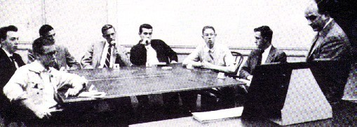
- In a control study of 36 participants taking part in 20 trials each, only three mistakes were made over a total of 720 trials.
- Participants in the experimental condition (n=50, male college students) were tested in groups of 7, 8 or 9. All the other members of the group were confederates of the experimenter.
- The confederates were instructed beforehand to give the same wrong answers on certain critical trials.
- The naïve participant was always the last or second to last to answer.
- The confederates gave the same wrong answer on 12 of the 18 trials. These were referred to as ‘critical trials’.

Results

- 26% of participants did not conform on any critical trials.
- 5% of participants conformed on every critical trial
- 74% of participants conformed at least once
- 32% was the basic conformity rate (total number of trials)

After the experiment, the participants were asked why they had conformed:

Some wanted to please the experimenter, and they thought that conforming was what the experimenter wanted; a few genuinely doubted their own eyesight; others reported that they did not want to appear different or be made to look a fool.

Conclusions:

This research is a demonstration of normative social influence. The finding that many did not want to appear different means that they did not internalise the answer, and would have returned to their original belief, so this is an example of compliance.

Evaluation of Asch’s study

Applications | - The applications of Asch’s study are wide. Juries can often be affected by the pressures to conform, and measures must be taken to avoid this by, for example, allowing the individual members of the jury to declare their opinion privately.  - Educators may be interested in an attempt to make children conform to socially acceptable behaviours.
Reliability | - Cultural differences: Smith and Bond (1996) analysed over 100 studies using an Asch type procedure and found that collectivist cultures were more likely to show greater conformity and individualist cultures, suggesting the conformity is influenced by the culture from which a person belongs.  - Contradictory findings: Perrin & Spencer (1980) replicated Asch’s study on engineering students and did not find support for the conformity effect. As Perrin & Spencer’s study was carried out much later than Asch’s, this might suggest that conformity can be affect by cultural changes over time.
Ethics (socially sensitive) | - The research could be considered socially sensitive as it implies that conformity is a negative trait, this is probably due to taking conformity out of its social context. Conformity could be considered essential for keeping society running smoothly. In some circumstances, conformity will enhance the individual’s chance of survival, and therefore to encourage non-conformity could be to the detriment of individual and society  - Advertisers may use the research to increase revenue for their clients by using the principles of normative social influence to manipulate people in order to sell more of their products. Some would consider this use of the research as unethical
Evaluation of method in terms of validity | - Asch used an all-male sample in his research. Other research has found that women tend to be more conforming than men (although this is not a consistent finding). But taking Asch’s research on its own, this does not tell us how women would act, therefore the conclusions are only relevant for males.  - Like Sherif’s research, Asch’ study uses a trivial situation, and therefore may overestimate levels of conformity in a real-life environment

Additional evaluation that applies to both explanations

Individual Differences | There are individual differences in susceptibility to normative social influence. Some people have a greater need to be liked than others. This means that not everyone will be affected by the situation equally, and therefore it may be difficult to predict how any individual will respond to social pressures to conform.
Informational or Normative? | Deutsch and Gerrard suggest that NSI and ISI are two different processes and that people conform because of either one or the other. However, in reality, there may not be such a clear distinction and it may be difficult to assess exactly which influence is responsible for conforming behaviour, particularly in a real-life situation.

Notes

Variables that affect levels of conformity

Group Size
Asch manipulated the size of the majority to record the effect it had on the participant. Using his original procedure, he varied the number of confederates in the group. Participants were tested using either 1, 2, 3, 4, 8, 10 or 15 confederates.

Findings
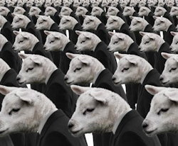
- Conformity was only 3% when there was one confederate
- Conformity was 13% when there were two confederates
- When there were three confederates, conformity increased to 33% and didn’t increase much beyond this regardless of the number of confederates
- In some conditions, a larger group of 15 confederates led to slightly less conformity, maybe because the participant was more likely to become suspicious when there was such a large group

Unanimity
Asch wanted to see if one person dissenting from the majority would affect the likelihood of the participant conforming

Findings
- When the participant had one (confederate) ally who gave the right answer before the participant answered, conformity dropped to 5.5%
- Asch found that when the confederate dissenter gave a different answer from the majority, but that answer was still incorrect, this was equally effective in reducing conformity in the participant. Asch concluded from this that the important factor was that the participant had support for deviating from the group, not support for his answer

Difficulty of the Task
Conformity increases when the task becomes more difficult. This relates to informational influence. People are more likely to conform to other people if they are unsure of the right answer or way to behave.

Findings
- Asch found that when he made the length of the lines more similar, conformity increased. This supports the view that conformity is more likely when the task is difficult

Notes

Conformity to Social Roles: Zimbardo’s Research
(An example of Identification)

Conformity to social roles refers to how an individual’s behaviour changes according to the expectation of behaviour in that particular situation. For example, a person may behave very differently depending on whether they are performing a job, socialising with friends, or looking after their children.

Zimbardo’s Stanford Prison Study

Aims:
- To test the dispositional versus the situational hypothesis. Are prison guards violent because they have violent personalities, or do their roles make them behave that way?
- To test the extent to which participants would adopt the role of prisoner or guard, even though the roles were determined randomly

Procedures:

- The study used a sample of 21 male student volunteers who were all rated as being psychologically stable
- Participants were randomly assigned to the role of either prisoner or guard. Zimbardo played the role of prison superintendent
- The study took place in the basement of Stanford University, which was converted into a mock prison. To add to the realism of the study, the prisoners were arrested at their homes by the local police, taken to the ‘prison’, stripped and deloused. They were dehumanised by wearing a loose fitting smock, a nylon stocking cap (to emulate a shaven head) and were referred to by number rather than name. Guards were deindividuated by wearing a uniform, reflective sunglasses and being referred to only as ‘Mr. Correctional Officer’
- The guards were told to keep the prisoners in line, but other than that, no specific instructions were given about how each group should behave. No physical violence was allowed. The study was scheduled to last for two weeks

Findings:

- Within a day the prisoners had rebelled and ripped off their numbers. The guards responded by locking them in their cells and taking away their blankets
- As the study progressed, the guards became increasingly sadistic. Prisoners were humiliated, deprived of sleep, made to carry out demeaning tasks (such as cleaning the toilets with their bare hands).
- The prisoners became depressed and submissive. Some showed signs of serious stress. One prisoner was released after 36 hours due to fits of crying and rage. Three more were released with similar symptoms during the next few days.
- The study was called to a halt after six days due to the unforeseen effects on the prisoners

Conclusions:

- The study supports the situational hypothesis, rather than the dispositional hypothesis. This is because participants adopted the behaviour associated with the role they were assigned, even though those roles were randomly determined, and no psychological abnormality was found to be present in the participants before the study began
- Conforming to social roles leads people to behave differently to how they normally would

Evaluation of Zimbardo’s Research

Applications | - Although Zimbardo intended his research to be used to reform the prison system, this does not seem to have happened. Reforms were made initially, particularly in juvenile institutions, but overall, conditions in prisons have not improved
Reliability | - Zimbardo didn’t fully support the situational hypothesis as not all the guards behaved equally aggressively towards the prisoners. Some were reluctant to exercise their authority, whereas others were seen as the ringleaders. This suggests that individual differences do play a part in the way someone responds to role expectations  - Reicher & Haslam replicated Zimbardo’s study in 2002, and this replication was broadcast by the BBC. The findings were very different to Zimbardo’s. The guards were unwilling to impose authority over the prisoners, who rapidly took charge of the prison. Following the breakdown of authority in the prison, both groups attempted to establish a fair and equal social system. When this failed, a small group of prisoners took control and the study was called off. This could suggest that Zimbardo’s findings may have been a ‘one off’, and caused by flaws in the methodology of the original study. It could also suggest that Zimbardo’s study lacks temporal validity and that people are now less likely to conform to the demands of a role if it leads to a negative outcome for others. It may also be that social roles are less rigidly defined now than they were in the past
Socially sensitive research/ethics | - Zimbardo has been criticised for not accurately assessing the potential impact on his participants, and failing to call a halt to the procedure soon enough when it became clear that some of those taking part were experiencing psychological harm. Partly this was due to Zimbardo taking on the role of prison superintendent, and therefore not creating enough distance from the procedure to be able to maintain professionalism in his role as psychologist
Evaluation of the research method in terms of its validity | - Zimbardo’s involvement in the procedure of the study could have had an influence on the behaviour of the participants. He could have unknowingly cued them to behave in a particular way (investigator effects). The artificiality of the situation could have led to demand characteristics being displayed

Notes

Obedience

Milgram’s original 1963 study into obedience

Aims:

- Milgram (1963) was interested in researching how far people would go in obeying an instruction if it involved harming another person.
- His research aimed to disprove the belief, following the Nazi atrocities, that ‘German’s are different’. He believed that in the right circumstances anyone is capable of performing an evil act

Procedure:

- Volunteers were recruited for a study investigating the effects of punishment on learning. Participants were 40 males, aged between 20 and 50, from a range of occupations.
- At the beginning of the experiment they were introduced to another participant, who was actually a confederate of the experimenter. They drew straws to determine their roles – learner or teacher – although this was fixed so that the confederate was always the learner.
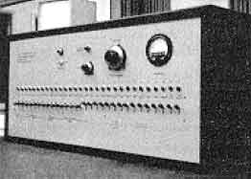
- The “learner” (Mr. Wallace) is then taken to an adjoining room and strapped to a chair and attached to electrodes so that he could receive shock from an electricity generator. After he has been read a list of word pairs, the "teacher" tests him by naming a word and asking the learner to recall its partner/pair from a list of four possible choices.
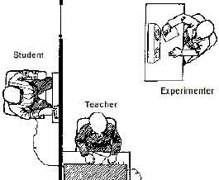
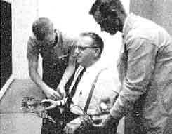
- The teacher is told to administer an electric shock every time the learner makes a mistake, increasing the level of shock each time. There were 30 switches on the shock generator marked from 15 volts (slight shock) to 450 (danger – severe shock). Unbeknown to the participant, no actual shocks are received by the confederate and his protests are from a taped pre-recording.
- The learner gave mainly wrong answers (on purpose) and for each of these the teacher gave him an electric shock. When the teacher refused to administer a shock the experimenter was to give a series of orders / prods to ensure they continued.

Results

- All 40 of the participants in the original study obeyed up to 300 volts
- Overall, 65% of the participants gave shocks up to 450 volts (obeyed) and 35% stopped sometime before 450 volts.
- During the study many participants showed signs of nervousness and tension including trembling, stuttering, digging fingernails into their flesh, indicating that although they were obeying, they were not enjoying what they were doing. Three of the participants experienced seizures.

Conclusion

- Ordinary people are likely to follow orders given by an authority figure, even to the extent of killing an innocent human being. Obedience to authority is ingrained in us all from the way we are brought up.

Evaluation of Milgram’s Obedience Research

Applications | - The research has many applications. It has been applied to explain pilot error in air crash disasters, when the authority of the captain is not questioned by the co-pilot or cabin crew because of the authority that the captain has, therefore the research can be used in training to alert those in subservient positions to the dangers of blind obedience.
Reliability | - The laboratory based experiment has been replicated many times and the high levels of obedience have been shown with other populations, across genders, in different eras and in different situations. In one study by Hofling et al, (1966) 21 out of 22 nurses broke hospital rules by preparing to administer twice the maximum dosage of a drug to a patient after receiving a phone call from an unknown doctor.
Socially Sensitive Research | - Milgram and his supporters have used this research to state that this can explain the atrocities committed by the Nazis in the 1930s and 1940s. Critics of this stance argue that this simplifies the holocaust to a “I was just following orders” defence, whereas in reality, many Nazis supported the final solution, believing it was the right course of action. Therefore, Milgram’s research is socially sensitive as some people are concerned that it removes the responsibility from many of the Nazis and their followers (Mandel, 1998).
Evaluation of method in terms of validity | - It has been suggested that Milgram’s study lacks mundane realism and that the participants were merely displaying demand characteristics, role-playing their anxiety because they did not think it was a real situation (lack of experimental realism). If this is true it would mean that the results could not be generalised to real-life situations. However, the fact that the obedience effect has been replicated in natural settings suggest that the results are generalisable  - Milgram’s study has been criticised for being highly unethical. As well as being deceived about the nature of the study and being pressured to continue when they wanted to quit, participants experienced a great deal of stress as a result of going through the procedure, which some believe is not acceptable.

Notes

Explanations of Obedience

Agentic State
Milgram suggested that people operate on one of two levels. Most of the time we are in autonomous mode. This means that we feel responsible for our own behaviour and therefore we are likely to act according to law and conscience, as we know we are accountable for our actions. However, in certain situations, an individual may slip into agentic state. This occurs when the individual feels able to pass responsibility for their actions onto an authority figure. It is so called because the individual in this state regards themselves as an ‘agent’ of the authority figure and no longer feels responsible or accountable for their actions. This allows them to act in ways that would not be possible if they were in autonomous mode.

Research Evidence
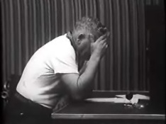
Film evidence and transcripts from Milgram’s study show that many of the participants were reluctant to go on with the procedure, but were more willing to do so when they were assured by the experimenter that they were not responsible for the outcomes and that the experimenter would take full responsibility if anything happened to ‘Mr. Wallace’. This is evidence that the participants were operating in agentic mode.
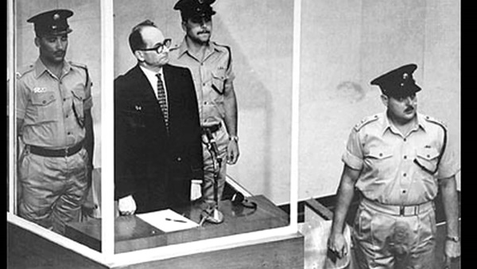
Real World Examples
There have been many examples in history where individuals who have committed atrocities have attempted to blame their actions on the authority figure by saying ‘I was just following orders’. Notable examples include Adolph Eichmann, who orchestrated the ‘final solution’ (the Nazi plan of mass extermination of European Jews) and William Calley, who sent his troops into My Lai during the Vietnam war to massacre the inhabitants of the village.
Adolph Eichmann on trial
Useful Applications
Both Eichmann and Calley were convicted of their crimes – their defence of ‘only following orders’ was not accepted. Therefore, if we can educate people to recognise the dangers of blind obedience to malevolent authority, and make sure people understand that they will be accountable for their actions, then we may reduce the amount of destructive obedience in society

Legitimate Authority
People have been socialised into acting on the requests of a legitimate authority. We tend to obey those with authority because we assume they know what they are doing. If someone has legitimate authority they have a role that is defined by society that gives them a right to exert their control over others. We may obey these people because we trust them, or because we believe that they have the power to punish us. Legitimate authority may come from a person’s status in society, which may be conveyed by a uniform, or their position in the family structure.

Research Evidence
Milgram found that when he moved his procedure to a seedy office and the experimenter was apparently just a member of the public, the obedience rate dropped from 65% to 48%. This supports the role of legitimate authority in obedience as the white-coated experimenter at Yale University would have been perceived has having greater status and therefore more legitimate authority.
Bickman (1974) found that 92% of pedestrians obeyed an order to give a stranger money for a parking meter when the person giving the order was dressed as a security guard, compared to only 49% when he as dressed in ordinary clothes. This supports the view that wearing a uniform increases the perceived legitimacy of the authority figure and leads to increased obedience.

Notes

The Role of Situational Variables in Obedience (including proximity, location & uniform)

Proximity
This can refer to how close the person is to the consequences of their actions when obeying an authority figure. Milgram found that the distance between ‘Mr Wallace’ and the participant influenced the obedience rate. The further away the participant is from ‘Mr. Wallace’, the more able they are to avoid witnessing the consequences of their obedient behaviour, and therefore the more likely they are to obey.
The proximity of the participant to the experimenter also has a bearing on the obedience level. This is probably because the pressure the participant feels to obey the experimenter is lessened if he is not in the same room

Research Evidence
Milgram found that:
- when the teacher and learner were brought into the same room, obedience dropped to 40%.
- When the teacher had to force the learner’s hand onto an electrode plate to deliver the shock, obedience dropped to 30%

Both of these findings support the view that when the teacher is faced more directly with the consequences of their actions (proximity is increased), obedience is less likely. Therefore, in the original experiment it is easier for the teacher to obey as they are separated from the learner by a wall.

- When the experimenter left the room and delivered his instructions by telephone, obedience dropped to 20%

Location
Location can have an effect on obedience rates because some locations increase the perceived legitimacy of the authority figure. For example, the experimenter in Milgram’s study had a high amount of perceived authority because he was attached to a very prestigious institution (Yale University). Therefore, we would expect obedience to that authority figure to be higher than if the study had have been carried out in a less prestigious institution.

Research Evidence
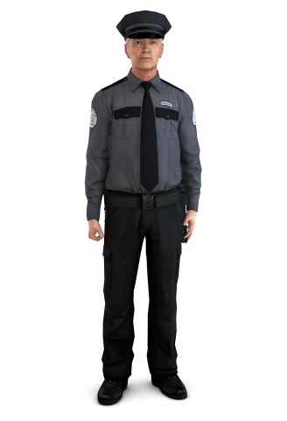
Milgram found that when he moved his procedure to a seedy office and the experimenter was apparently just a member of the public, the obedience rate dropped from 65% to 48%. This supports the view that the greater prestige of Yale University led to a higher obedience rate and that a change in location can result in lower obedience rates.

Uniform
A uniform can give the perception of greater authority, and therefore we would expect that obedience rates would be higher if the person giving the order was wearing a uniform

Research Evidence
Bickman (1974) found that 92% of pedestrians obeyed an order to give a stranger money for a parking meter when the person giving the order was dressed as a security guard, compared to only 49% when he as dressed in ordinary clothes. This supports the view that wearing a uniform increases the perceived legitimacy of the authority figure and leads to increased obedience.
In Milgram’s research, the white lab coat of the experimenter helped to establish his authority

Notes

The Role of Dispositional Factors in Obedience:
The Authoritarian Personality

Some psychologists have attempted to establish whether certain personality traits (dispositional factors) make someone more likely to obey an authority figure. Adorno carried out research that linked a personality type that he called ‘The Authoritarian Personality’ with high levels of obedience.

Procedure

- Adorno studied over 2,000 American students, mainly from white middle class backgrounds
- He interviewed them about their political beliefs and their early childhood experiences
- He used projective tests (e.g. the Rorschach inkblot test) to gain access to peoples thoughts and determine whether they were racially prejudiced

Results

- Adorno found that people who had been brought up by strict parents, who tended to use harsh physical punishments, were likely to grow up to be very obedient.
- Children raised in these conditions quickly learn to obey and develop a strong respect for authority
- They believe in the need for power and toughness, and submission to authority

Conclusions

- Adorno concluded that the harsh physical punishments made the children feel hostile and angry towards their parents. This hostility is repressed and displaced onto others, often those of a different racial group, or those who are perceived as being weak

From his research, Adorno developed the ‘F Scale’, (‘F’ stands for fascist), a questionnaire designed to measure the authoritarian personality. The scale has 30 questions measuring nine different personality dimensions

Supporting Evidence

Zillmer et al (1995) reported that 16 Nazi war criminals scored highly on three of the F Scale dimensions, but not on all nine. This partially supports the view that the authoritarian personality is linked to high levels of obedience.
Elms & Milgram (1966) found that the highly obedient participants in Milgram’s study scored significantly higher on the F scale than the less obedient participants. This supports the view that the authoritarian personality is linked to high levels of obedience.

Other evaluation

The research only partially supports the idea that the authoritarian personality is linked to high levels of obedience, as it would seem from Zillmer’s research that only some constructs are relevant when predicting who are likely to be most obedient

As this is correlational research, we cannot establish a cause and effect link between authoritarianism and obedience. There may be another factor that coincides with both that is the cause of the greater obedience

The theory is politically biased. It presumes that only right wing individuals have a higher predisposition towards obedient behaviour. This may be an indication of researcher bias, where the views of the researcher have influenced the outcome of the research

Notes

Explanations of Resistance to Social Influence

Social Support
People are less likely to obey or conform if they have support from others for non-obedient or non-conforming behaviour. This may be because having people who around who are willing to remain independent, gives the person more confidence in their own views. It could also be because it makes the individual feel less conspicuous in their behaviour.

Research evidence

Milgram found that when there were two disobedient confederates present in the procedure, obedience in the real participant dropped dramatically to 10%. Conversely, when there were two obedient confederates, obedience rose to 92.5%. This demonstrates the power of social support (or lack of it) in obedient behaviour
Asch found that when the confederate dissenter gave a different answer from the majority, but that answer was still incorrect, this was equally effective in reducing conformity in the participant (to 5.5%). Asch concluded from this that the important factor was that the participant had support for deviating from the group, not support for his answer

Locus of Control
This refers to the extent to which individuals believe that they can control the events in their lives. Individuals with a high internal locus of control believe that events result primarily from their own behaviour and actions. Those with a high external locus of control believe that powerful others, fate, or chance primarily determine events. Those with a high internal locus of control have better control of their behaviour and tend to exhibit more political behaviours than externals and are more likely to attempt to influence other people; they are more likely to assume that their efforts will be successful. They are more active in seeking information and knowledge concerning their situation than do externals. The propensity to engage in political behaviour is stronger for individuals who have a high internal locus of control than for those who have a high external locus of control

Research evidence

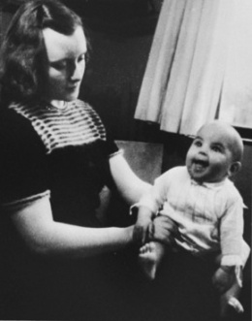
Elms and Milgram (1974) investigated the background of some of the disobedient participants from Milgram’s first four obedience experiments. They found that disobedient participants had a high internal locus of control and scored higher on a scale that measured their sense of social responsibility
Oliner & Oliner 1988) interviewed two groups of non-Jewish people who had lived through the Holocaust in Nazi Germany. They compared 406 people who had rescued Jews with 126 who had not done so. Oliner & Oliner found that the ‘rescuers’ were more likely to have scores demonstrating a high internal locus of control than the non-rescuers, and also scored more highly on measures of social responsibility.
However, Williams and Warchal (1981) studied 30 university students who were given a range of conformity tasks based on Asch’s procedure. Each student was also assessed using Rotter’s locus of control scale. They found that those who conformed did not score differently on the locus of control scale but they were less assertive, so assertiveness may have more to do with conformity than locus of control

Notes

Other evaluation

Oliner & Oliner’s research is important, as it shows that the effects of locus of control on social influence can be replicated in a real-life environment, not just in the laboratory. This increases the ecological validity of the research

However, not all the research supports the view that internal locus of control leads to less obedient or conforming behaviour. Williams and Warchal’s research suggests that another personality factor may be more important (assertiveness), at least as far as resisting conformity is concerned. Therefore, the research lacks reliability

The research is correlational and therefore it is not possible to establish a cause and effect relationship between the variables of internal locus of control and independent behaviour. There may be another factor that is associated with locus of control that causes independence. For example, it may be that certain parental styles lead to high internal locus of control and high levels of independent behaviour

Notes

Minority Influence

This refers to when an individual, or a small group change the behaviour and/or attitudes of the larger group. It is the opposite of conformity

Minorities are most likely to be successful if they demonstrate the following:
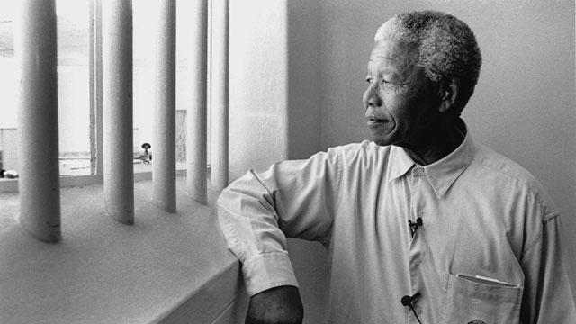
- Consistency – the minority will only be influential if they stick to their view over a period of time.
- Not dogmatic – There has to be a degree of flexibility, not rigidly sticking to the point in light of contradictory information
- Be seen to be acting from principle – not out of self-interest but for the benefit of the majority
- Make sacrifices for the cause
- Are similar to the majority, in terms of class, age, and gender
- Advocate views that are consistent with social trends

Research study supporting the role of consistency in minority influence:

Moscovici et al (1969) Blue-Green Study

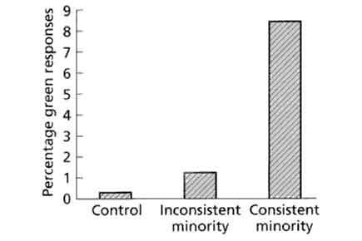
Aim : To investigate the effects of a consistent minority on a majority. Moscovici (1969) conducted a re-run of Asch’s experiment, but in reverse. Instead of one subject amongst a majority of confederates, he placed two confederates together with four genuine participants. The participants were first given eye tests to ensure they were not colour-blind.
Procedure : They were then placed in a group consisting of four participants and two confederates. They were shown 36 slides which were clearly different shades of blue and asked to state the colour of each slide out loud. In the first part of the experiment the two confederates answered green for each of the 36 slides. They were totally consistent in their responses. In the second part of the experiment they answered green 24 times and blue 12 times. In this case they were inconsistent in their answers. Would the responses of the two confederates influence those of the four participants? In other words, would there be minority influence?
Results : In condition one it was found that the consistent minority had an affect on the majority (8.42%) compared to an inconsistent minority (only 1.25% said green). A third (32%) of all participants judged the slide to be green at least once.
A third (32%) of al participants judged the slide to be green at least once.
Conclusion : Minorities can influence a majority, but not all the time and only when they behave in certain ways (e.g. consistent behaviour style).
Criticism : The study used the lab experiments – i.e. are the results true to real life (ecological validity)? Also Moscovici used female students as participants (i.e. unrepresentative sample), so it would be wrong to generalize his result to all people – they only tell us about the behaviour of female students.

Research supporting the role of flexibility in minority influence

Nemeth (1986) created groups of three participants and one confederate. They had to decide how much compensation to pay the victim of a ski lift accident. When the confederate argued for a low amount and refused to change his position, he had no effect on the majority. However, when he compromised a little, he was much more influential with the majority and they were more willing to lower the amount offered. This demonstrates how flexibility is important and challenges the view that consistency is an effective way to influence the majority
The role of social influence processes in social change

Compliance vs Internalisation

Social change occurs when a whole society adopts a new belief or way of behaving which then becomes the ‘norm’. This can be positive (more liberal attitudes towards homosexuality) or negative (anti-immigration attitudes due to the belief that immigration is to blame for the economic downturn). Social change occurs when a minority view challenges the majority view and is eventually accepted by the majority.

Moscovici (1980) claims that majorities and minorities achieve influence through different processes. Majority influence usually results in public compliance where an individual changes their behaviour to fit in and this is only likely to last for the amount of time the individual is with the group. Minorities, however, use informational social influence to persuade those in a majority to change their views. Minorities are aiming for conversion and not compliance. This leads to internalisation, in other words, a permanent change.

Social cryptoamnesia (or the dissociation model)

The majority group take on board the views and ideas of the minority but either forget where they came from or deliberately disassociate themselves. This is because minorities tend to have a negative image that members of the majority don’t want to be associated with, so while they become persuaded by the arguments of the negative minority, they seek to distance themselves from the source of the information

The snowball effect

The more the minority group grows, the more influential it becomes. Social influence accelerates (this happens when something ‘goes viral’ on social media). Once a few members of the majority start to move towards the minority, then other people from the majority start to pay attention and the movement gathers momentum, until it becomes the majority view.

Notes

An example of how social change can be explained by social influence research:

In the early 20th Century a small minority group of women, the suffragettes, resisted conformity and disobeyed the authority of the law to fight for the right of women to vote in Parliamentary elections.
- The women of the Pankhurst family led this militant campaign. Emmeline Pankhurst was an educated woman with politically active parents: she was sent to school in Paris (a ‘revolutionary’ setting) and was taken to her first women’s suffrage meeting at the age of 14. She brought her daughters up within the suffrage movement. She married a barrister who campaigned for women’s rights and supported her views. She was also surrounded by a small circle of politically active women. | Similar ‘class’ to the politicians she was trying to persuade  Consistency
- Emmeline and her daughters rejected being told that they were not entitled to the same basic rights as men who could vote for/against those authorities. They did not accept the legitimacy of a government which would not allow them to vote. | Acting out of principle
- They were frequently arrested and imprisoned for their provocative campaigning methods (leading riots, throwing rocks at the prime minister’s carriage, chaining themselves to railings) and in one famous case (Emily Davison) threw herself to her death, trampled by the king’s horse. | Making sacrifices for the cause
- The suffragettes must have believed that they could achieve their goals of votes for women, as women’s suffrage had already been achieved in Australia and New Zealand. | In line with some current trends in similar countries on universal suffrage
- The Suffragettes achieved their goal through gradual change. Women over 30 were allowed to vote in 1918. Women over 21 were allowed to vote in 1928. | The snowball effect, the movement grew through society
- Feminists achieved the introduction of laws on equal pay and sex discrimination by the 1970s. but are still campaigning for full gender equality in society in 2015 | Social cryptoamnesia (people today often don’t identify with being a feminist)

Notes

