Synaptic transmission is the passing on information through neurons.
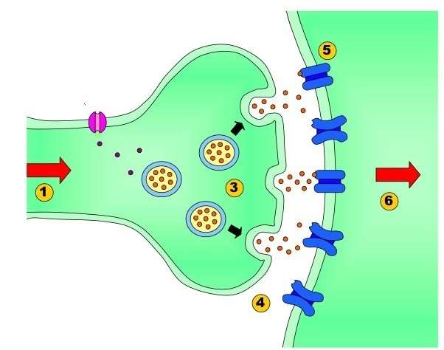

Electrical impulses are passed through the axon of a neuron to the synaptic endings/terminal. The electrical impulse cannot go through the gap between neurons, the synaptic cleft.

Instead the electrical impulse triggers vesicles containing neurotransmitters to move towards the membrane of the pre-synaptic neuron. The vesicles fuse with the presynaptic membrane.

Then release neurotransmitters into the synaptic cleft.

Where they then bind to the receptors on the post-synaptic neuron.

This triggers a signal in the post-synaptic neuron. Neurotransmitters can have an excitatory effect on the receiving neuron (making them more likely to fire) or an inhibitory effect (making them less likely to fire).

