Memory (unit 1) – tracking test 1
Q1 – Long term memory can be divided into three distinct stores. Name them? (1 mark)

Q2 – Give a brief definition of each of the above (3 marks)
a)

b)

c)

Q3) Fill in the following table – ½ mark for each correct answer (4 marks)

 | Capacity | Encoding | Duration
Sensory register | a) | Dependent on the sense detecting it. So for iconic, it is visual, for echoic, it is acoustic. | b)
STM | c) | d) | e)
LTM | f) | g) | h)

Q4) in terms of the duration for STM, What percentage of trigrams were remembered in Peterson and Peterson’s study after a) 3 seconds __________ b) 18 seconds __________ (2 marks)

Q5) The first model of memory was proposed by Atkinson and Shiffrin. What was it called? (1 mark)

Q6) When passing information from STM to LTM, what must happen to the information according to Atkinson and Shiffrin? (1 mark)

Q7) What assumption made by Atkinson and Shiffrin does the case study of Clive Wearing allow us to criticise? (1 mark)

Q8) what part of the brain allows us to remember episodes ________________________ and what part of the brain allows us to (unconsciously) remember how to do skills? ___________________________ (2 marks)
Q9) In relation to coding in STM, In Baddeley’s study in 1966, recall of acoustically similar lists were remembered poorly, with a correct recall of about ___________% . With other acoustically dissimilar lists, accurate recall was much better, between ____ to ____% of the words were recalled in order. (2 marks)

Q10) accurately label the letters in the diagram below (6 marks) (letter f is the same word three times)
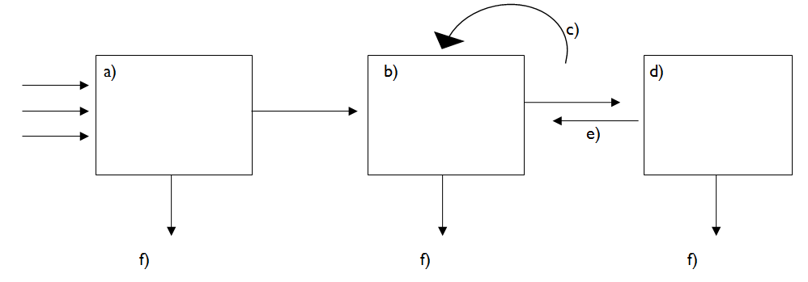
Q11) What model, devised by Baddeley and Hitch, aimed to replace the notion of the single unitary Short-term memory store as proposed by Atkinson and Shiffrin (1 mark)

--------------------------------------------------------------------------------------------------------------------------------------
Reflections
I scored ______ out of 24 which is a grade _________ (0-6=U; 7-9=E; 10-12=D; 13-15=C; 16-18=B; 19-21=A; 22-24=A*)

Answers
Memory (unit 1) – tracking test 1
Q1 – Long term memory can be divided into three distinct stores. Name them? (1 mark)
Episodic, semantic and procedural
Q2 – Give a brief definition of each of the above (3 marks)
- Episodic = Memory for things that have happened in our lives (episodes)

- Semantic = Memory of knowledge. Factual information which we know

- Procedural = Memory for skills that we acquire

Q3) Fill in the following table – ½ mark for each correct answer (4 marks)

 | Capacity | Encoding | Duration
Sensory register | Huge | Dependent on the sense detecting it. So for iconic, it is visual, for echoic, it is acoustic. | From ½ second to up to 2 seconds
STM | 7 + or – 2 | Mainly acoustic | Up to 18 seconds  Or  Between 15 – 30 seconds
LTM | unlimited | Mainly semantic | Up to a life time

Q4) in terms of the duration for STM, What percentage of trigrams were remembered in Peterson and Peterson’s study after a) 3 seconds 90% b) 18 seconds 5% (2 marks)

Q5) The first model of memory was proposed by Atkinson and Shiffrin. What was it called? (1 mark)
The Multi-Store Model of Memory
Q6) When passing information from STM to LTM, what must happen to the information according to Atkinson and Shiffrin? (1 mark)
Maintenance rehearsal
Q7) What assumption made by Atkinson and Shiffrin does the case study of Clive Wearing allow us to criticise? (1 mark)
That LTM is not a single unitary store
Q8) what part of the brain allows us to remember episodes The hippocampus (also frontal and temporal lobes) and what part of the brain allows us to (unconsciously) remember how to do skills? The cerebellum (also Basal Ganglia and Motor cortex) (2 marks)
Q9) In relation to coding in STM, In Baddeley’s study in 1966, recall of acoustically similar lists were remembered poorly, with a correct recall of about 10% . With other acoustically dissimilar lists, accurate recall was much better, between 60-80% of the words were recalled in order. (2 marks)

Q10) accurately label the letters in the diagram below (6 marks) (letter f is the same word three times)
a = Sensory register b = short-term memory c= maintenance rehearsal d = long term memory e = retrieval f = forgetting

Q11) What model, devised by Baddeley and Hitch, aimed to replace the notion of the single unitary Short-term memory store as proposed by Atkinson and Shiffrin (1 mark)
The working memory model

--------------------------------------------------------------------------------------------------------------------------------------
Reflections
I scored ______ out of 24 which is a grade _________ (0-6=U; 7-9=E; 10-12=D; 13-15=C; 16-18=B; 19-21=A; 22-24=A*)

