Research Methods Psychology Pack:

Year 1

The Specification

Research Methods: Year 1

You will need to be able to demonstrate knowledge and understanding of the following:
- Research methods
- Scientific processes
- Techniques of data handling and analysis.
- It is also important that you’re aware of their strengths and limitations.
 | Notes? | Revised?
Methods and techniques
Experiments
- What is a lab experiment?
- What are the advantages of a lab experiment?
- What are the disadvantages of lab experiments?

- What is a field experiment?
- What are the advantages of a field experiment?
- What are the disadvantages of field experiments?

- What is a natural experiment?
- What are the advantages of a natural experiment?
- What are the disadvantages of natural experiments?

- What is a quasi experiment?
- What are the advantages of a quasi experiment?
- What are the disadvantages of a quasi experiment?

- How to design an experiment.

Correlational analysis
- What is a correlational study?
- What is the difference between correlations and experiments
- What is a positive/negative correlation?
- What are the disadvantages of a correlational study?
- What are the disadvantages of correlational study?
- How to design a correlation

Observational techniques
- What is an observational study?
- What is a naturalistic observation? (+advantages and disadvantages)
- What is a controlled observation? (+advantages and Disadvantages)
- What is a covert and overt observation? (+ advantages and disadvantages)
- What is a participant and non-participant observation? (+ advantages and disadvantages)
- How to design an observation

Self report techniques
- What is a questionnaire? (+ advantages and disadvantages)
- What is an interview?
- What is a structured interview? (+ advantages and disadvantages)
- What is an unstructured interview? (+ advantages and disadvantages)
- How to design questionnaires and interviews.

Case studies
- What is a case study?
- What are the advantages of case studies?
- What are the disadvantages of case studies?

Content analysis
- What is a content analysis?
- What are the advantages of a content analysis?
- What are the disadvantages of a content analysis?

Investigation design
- Aims
-stating aims,
-difference between aims and hypotheses

- Hypotheses
- Directional/one tailed hypothesis
- Non-directional/ two tailed hypothesis
- Null hypothesis
- Operationalised hypotheses

- Sampling
- The difference between population and sample
- Opportunity sample (+advantages and disadvantages)
- Random sample (+advantages and disadvantages)
- Volunteer sample (+advantages and disadvantages)
- Systematic sample(+advantages and disadvantages)
- Stratified sample (+advantages and disadvantages)

- Pilot studies and the aims of pilot studies

- Experimental design
- Independent groups (+advantages and disadvantages)
- Repeated measures (+advantages and disadvantages)
- Matched pairs (+advantages and disadvantages)

- Observational design
- Time and event sampling (+ advantages and disadvantages)
- Behavioural categories? (you must be able to create operationalised behavioural categories)

- Questionnaire construction
- The use of open and closed questions (+advantages and disadvantages)
- Designing interviews

- Variables
-Independent variable
-Dependent variable
-Co-variables (correlation)
- Operationalisation of variables
-Extraneous variables (and how they can be controlled)
-Confounding variables (and how they can be controlled)

- Control
- random allocation & how to do this
- counterbalancing & how to do this
- randomisation & how to do this
- standardisation & how to do this

- Demand characteristics and investigator effects

- Ethics
- the role of BPS guidelines
- ethical issues in the design and conduct of psychological studies
- dealing with ethical issues in research

- The implication of psychological research for the economy

- Reliability
-what is reliability?
- definition of inter-rater reliability and how this is used to assess the reliability of observations
- Validity
- what is validity?
- types of validity – internal and external (ecological, temporal, population)

Data handling and analysis
- Quantitative and qualitative data
- the distinction between these data collection techniques
- Primary and secondary data (+ advantages and disadvantages)
-including meta-analysis (+advantages and disadvantages)
- Descriptive statistics
Measures of central tendency
- Mean (+ advantages and disadvantages) and calculation
- Mode (+ advantages and disadvantages) and calculation
- Median (+ advantages and disadvantages) and calculation
Measures of dispersion
- Range (+ advantages and disadvantages) and calculation
- Standard Deviation (+ advantages and disadvantages)

Calculation of percentages
Positive, negative and zero correlations
- Presentation and display of quantitative data
-graphs
-tables
-scattergrams
-bar charts
- histograms
- Distributions
-normal and skewed distributions
-characteristics of normal and skewed distributions
- Analysis and interpretation of correlation, correlation co-efficients
- Qualitative data analysis - content analysis and thematic analysis
- Introduction to statistical testing
- calculating of the sign test
- interpreting the significance of the sign test

Introduction

Psychology is often defined as ‘the science of mind and behaviour’. In order for Psychology to be considered a science (and therefore a legitimate academic subject) it has to follow the rules of science. This means that psychologists can’t just come up with ideas that they believe are true, or essentially opinions.

Psychologists aim to gather evidence about behaviour whilst trying to remain objective and free from bias (personal views). One way this is achieved is through using the scientific method. The scientific method is a way of gathering evidence in an orderly, structured manner that can enable psychologists to develop theories and draw conclusions about behaviour.

Research methods are a vital component of studying Psychology and this pack will take you through the various methods that are used within Psychological research, what kind of data can be gathered and how the data is analysed. Get ready for the journey!

Research Methods
A variable is anything that can vary, i.e. changed or be changed, such as memory, attention, time taken to perform a task, etc.

Experimental Methods

Psychologists use the experimental method to identify the "effect" one variable has on other variables. In other words….does one variable "cause" other variables to change. This is called cause and effect. Being able to conduct research that establishes cause and effect is a key feature of scientific research.

However establishing cause and effect is not easy and requires researchers to conduct studies that not only follow the scientific method, but also classify as "true experiments".

In a true experiment, there must be a control condition and an experimental condition and participants must be randomly assigned to these conditions. This is so that the researcher can make fair comparisons between the two groups.

A researcher manipulates the independent variable (IV) in order to test its effect on the dependent variable (DV).
Everything else is kept the same (controlled) between the two conditions.

If there is a significant difference in the results of the two groups, we can conclude that the independent variable caused the change in the dependent variable (cause and effect).

Independent and dependent variables

In an experiment, a researcher manipulates the independent variable (IV) and measures the effect of this on the dependent variable (DV).
All other variables that might potentially affect the DV should remain constant. This means the researcher can be confident that the effect on the DV, was due to the change in the IV and nothing else.

Independent Variable: A variable that is manipulated by the researcher – or changes naturally.

Dependent Variable: The variable that is measured by the researcher. Any effect on the DV should be caused by changes in the IV.

Levels of the IV

In order to test the effect of the IV we need different experimental conditions. The control condition and the experimental condition.

- The control condition provides a baseline measure of behaviour without experimental treatment.
- The experimental condition is the one in which there has been researcher manipulation. This is the condition in which the researcher is particularly keen to see if a difference in behaviour has occurred.

Operationalisation

Psychologists are interested in a range of behaviour; intelligence, aggression, social anxiety etc. It’s important when studying them that they are defined.

Operationalisation is clearly defining variables so they can be measured.
Aims and Hypotheses

Before a researcher begins to investigate an area of interest, they will write an aim and a hypothesis. You need to be able to identify the difference between these and also be able to write both of them.
Aim
The aim is a general statement of what the researcher intends to investigate, essentially the purpose of the study. Aims tend to be developed from theories. For example, this study aims to investigate whether drinking energy drinks makes people more talkative.

Hypotheses
Once the aim is written, the researcher needs to formulate a hypothesis. A hypothesis is a testable statement predicting the outcome of the study which is made at the start of the study.

There are two hypotheses that a written - the alternate/experimental hypothesis and the null hypothesis

- Null hypothesis – this predicts that there will be no difference or relationship.
- Alternate/experimental hypothesis – these predict a difference or relationship and can be directional or non-directional.

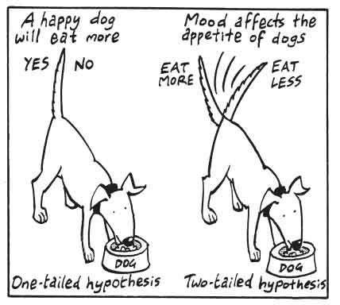
Directional hypothesis (also called a one-tailed hypothesis)

The researcher makes it clear what sort of difference or relationship that may be seen between the 2 conditions. The hypothesis may use words like ‘less’ ‘more’ ’higher’ or ‘lower’.

For example,
People who drink redbull will become more talkative than people who don’t.
Or… People who drink water will be less talkative than people who drink redbull.

Non directional hypotheses (also known as a two-tailed hypothesis)
Non-directional hypotheses are used when there has been no previous research to suggest what direction the research will go in or the previous findings have been contradictory.

Therefore, the researcher simply states there ‘will be a difference’ or ‘there will be a relationship’ between the 2 conditions. The direction of the outcome is not mentioned.

For example,
There will be a difference in talkativeness of people who drink redbull compared with people who drink water.

How to write an experimental hypothesis:

In order to write a hypothesis there are a few factors you need to be clear on before you can begin.

- What are the IV and the DV?
- How is the IV manipulated e.g. what are the levels of the IV
- How has the DV been measured exactly? E.g. how has it been operationalised?
- Should the hypothesis be one tailed or two tailed?
- Write your hypothesis- Put it all together!

Worked example:

The aim is to investigate whether a new drug (axocalm) reduces anxiety in patients with phobias. No previous research has been conducted on the effectiveness of this drug.

Step 1:
Identify the DV- what is being measured? The answer is anxiety.
Identify the IV- what is being manipulated? The answer is whether they are given the drug or not

Step 2:
In order to test the effect of the IV we need different experimental conditions. If we simply gave some participants the drug, how would we know if it reduced their anxiety? We need a comparison. We could either:
- Compare participants anxiety levels before and after talking the drug
- Compare two groups of participants- those who take the drug and those who do not take the drug

Step 3:
Operationalise the DV- how exactly is anxiety being measured?
In this example, they have not specified how anxiety is measured so we need to come up with a sensible way to measure anxiety e.g. a self report scale.

“On a scale of 1-10 (1=not anxious at all and 10= highly anxious) how do you feel now?”

Sometimes exam questions will give you information about how the DV has been measured so you need to identify this from the scenario and include it in your hypothesis.

Step 4:
Identify from the information you have been given if you should write a one-tailed or two-tailed hypothesis.

In this case, they have said that no previous research has been conducted so that informs us that we should write a non-directional (two tailed) hypothesis.

Step 5:
Put all of this information together into a written testable statement.

Below is an example of a template you can use to write nearly every non-directional hypothesis:

There will be a difference in ________(DV), measured by ___________( operationalised DV) for participants who ________(IV - condition 1)compared to those who __________(IV -condition 2).

The answer is on the next page.
Answer:
There will be a difference in anxiety, (measured on a self-report scale where 1=not anxious and 10= very anxious) for participants who are given the drug compared to those who are not given the drug.
Writing a directional (one-tailed) hypothesis:
Follow steps 1-3, then you will identify in step 4 that previous research has been conducted that has demonstrated the direction the researcher is likely to go in e.g. the drug does reduce anxiety.
You will have to make sure you include in your answer which group will be more/less anxious.
Template to use for directional hypotheses:
Participants who _________ (IV - cond.1) will be more/less ___________ (operationalised DV) than participants who ___________ (IV -cond. 2).

Your answer would then look like this:

The participants who are given the drug will feel less anxious (measured on a self-report scale where 1=not anxious and 10= very anxious) than participants who are not given the drug.

Writing correlational hypotheses
The difference when writing a correlational hypothesis is simple.
We are no longer investigating a difference between two conditions, like in an experiment, but we are looking at a relationship between two co-variables. There is no IV or DV in a correlation.
Correlational hypotheses can still be directional or non-directional.
The Co-variables must still be clearly operationalised.
Worked example:
The aim is to investigate whether there is a correlation between the price of chocolate and how tasty it is.

Template:

There will be a correlation between __________(co variable 1) and __________(co variable 2).

Non directional example- There will be a correlation between the price of a chocolate bar and its tastiness rating (out of 20).

Directional example - There will be a positive/negative correlation between the price of a chocolate bar and its tastiness rating (out of 20).

NB: Notice that when you write a directional correlational hypothesis you predict whether the correlation between the co-variables will be positive or negative.

Research Methods

In order for Psychologists to develop an understanding of the mind and behaviour they use a variety of methods to scientifically study people (and animals.) The next few pages will take you through the types of methods used, starting off with experiments.

Types of experiments:

All experiments involve a change in the Independent Variable (IV) with the researcher measuring the subsequent effects on the Dependent Variable (DV). How the IV changes and under what circumstances varies from one type of experiment to another.

Laboratory experiments:

Laboratory experiments are conducted in highly controlled environments. The researcher manipulates the IV and records the effects of the DV. The participants in a lab experiment can be randomly allocated to conditions. A lab experiment is therefore considered a ‘true’ experiment.
Strengths of Lab experiments:
- High control over extraneous variables meaning cause and effect can be established.
- Replication is possible due to the high level of control. This also means results can be checked for reliability.

Limitations of lab experiments:
- Participants are often aware of being tested – possible demand characteristics.
- Artificial environment means it may lack generalisability.
- Investigator effects may occur (unless it is a double blind experiment- this is when both the participant and the researcher conducting the experiment does not know the aims of the investigation)

Field experiments:
In field experiments the researcher still manipulates the IV and records the effects on the DV but the experiment is conducted in a real life setting.

Strengths of Field experiments:
- High ecological validity due to being conducted in a real-life setting.
- Behaviour is likely to be more valid & authentic (less demand characteristics).

Limitations of Field experiments:
- There is less control over extraneous variables (these will be different depending on the experiment).
- It is difficult to replicate them completely because they tend to be less controlled.
- Possible ethical issues if participants are unaware they’re being studied.

Natural experiments:

A natural experiment is where the researcher takes advantage of a naturally occurring IV and the effect it has on the DV. The experimenter has not manipulated the IV directly; the IV would vary naturally whether or not the researcher was interested.
The researcher cannot randomly allocate participants to conditions and/or has no control over the IV. This is not a ‘true’ experiment.

Note: it is the IV that is natural, not necessarily the setting.

Example: Romanian Orphan studies (Attachment topic). IV = adoption before or after the age of 6 months (naturally occurring/varying)
Strengths of Natural experiment:
- Provides opportunities for research that may not be otherwise conducted due to practical/ethical reasons e.g. does smoking when pregnant lead to behavioural problems in infants?
- They have high external validity because they involve the study of real-life.

Limitations of Natural experiments:
- A naturally occurring event may happen, rarely limiting generalisation to other situations.
- Participants may not be randomly, allocated to conditions.
Quasi – experiments:

Studies that are ‘almost’ experiments. The IV is not something that varies at all – it is simply a difference between people that exists. The researcher records the effects of this ‘quasi-IV’ on the DV.
The researcher cannot randomly allocate participants to conditions and/or has no control over the IV. This is also not a ‘true’ experiment.

Examples: Experiments where the IV is a variable such as age, gender, locus of control etc.
Strengths of Quasi- experiments:
- Carried out under controlled conditions & share the strengths of a lab experiment.

Limitations of Quasi- experiments:
- Participants are aware of being tested – possible demand characteristics.
- Participants cannot be randomly allocated and therefore there may be confounding variables.
Summary of key differences
Type of experiment | Environment conducted in: | Independent variable:
Lab | Controlled | Controlled
Field | Natural | Controlled
Quasi | Controlled | Naturally occurring
Natural | Natural | Naturally occurring

Control of variables

The key to an experiment is that the independent variable (IV) is manipulated (changed) to see how this affects the dependent variable (DV). Remember, the researcher only wants the IV to affect the DV. If however, there are other variables that may influence the IV or DV (and these are unwanted) these are extraneous variables.

Extraneous variables:

Any variable, other than the independent variable (IV), that may have an effect on the dependent variable (DV) if it is not controlled.
These variables can come from the participant (e.g. age, intelligence), the experimental situation (e.g. noise levels, temperature) or the experimenter (e.g. personality, appearance or conduct of the researcher)

Confounding variables:

Any variable, other that the independent variable (IV), that has not been controlled so do affect the DV. Therefore we cannot be sure of the true reason for the changes to the DV/difference found.

Demand characteristics:

Participants are not ‘passive’ in experiments and they may work out what is going on and change their behaviour to please the experimenter or even act negatively. Demand characteristics occur when a participant may receive a ‘cue’ from the researcher or the situation and so the participant changes their behaviour as a result.

Investigator effects:

Any effects of the investigator’s behaviour (conscious or unconscious) on the research outcome (DV). This may include everything from the design of the study, to the selection of and interaction with the participants during the research process.

Ways to minimise extraneous/confounding variables:

Randomisation:

Randomisation is the use of ‘chance’ in order to control for the effects of bias i.e. in a memory experiment that may involve participants recalling words from a list. The order of the list should be randomly generated so that the position of each word is not decided by the experimenter.

Standardisation:

This is using exactly the same procedures for all participants, such as the same environment, instructions and experience.

Reliability and Validity
Reliability and Validity are two very important concepts in research methods as they can affect the credibility of research findings. Psychologists must consider these when designing and conducting research and they are used to assess how good a piece of research is.

Validity

Validity refers to how accurate and representative the results are. There are two types of validity: Internal and External

NB: there is a third type of external validity know as population validity which refers to whether the experimental results can be generalised to other groups, ie women, different ages etc.

Reliability
Reliability refers to how consistent the results are. In other words, if the experiment is repeated, will the same or highly similar results occur again? If the answer is yes, the study can be said to possess high reliability. Reliability can be improved by developing consistent forms of measurement. There are two types: internal reliability and external reliability.

Internal reliability – refers to the extent to which a test is consistent within itself, for example, if someone was completing a questionnaire measuring high levels of obedience they should have the same score on each question on the questionnaire for it be considered to have internal reliability.
External reliability – refers to the extent to which a test is consistent over time. For example, if someone achieved 120 on the IQ test (Test of intelligence) if they were tested again in say 8 months time, we would expect them to achieve the same result. This would show the test to have external reliability.
Inter-observer reliability- refers to the extent to which two or more observers are in agreement on the behaviours they observe. We check for inter-rater reliability by correlating the two (or more) sets of observations to see if they correlate positively. If their correlation is +0.8 or above we would conclude that inter-observer reliability is high and that they have consistently observed the same behaviours.

Experimental Design
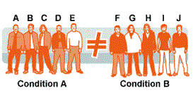
Experimental design refers to how the participants in an experiment will be used. A researcher can arrange his/her participants in one of three ways. Independent groups, repeated measures or matched pairs.
Independent groups:
An independent groups design is when two separate groups of participants experience two different conditions of the experiment.
Strengths: | Limitations:
- Order effects are avoided (when participants become aware of or bored with an experimental procedure).  - There are less likely to be demand characteristics because participants only take part in one condition of the experiment and are therefore less likely to pick up on cues. | - Individual differences between groups, otherwise called “participant variables”, may affect the results (what if one group has people who have a naturally higher IQ than people in the other group?) – to deal with this random allocation is used.  - A larger amount of participants are needed in this experimental design.
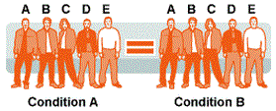
Repeated groups:
A repeated measures design is where all participants take part in both the conditions.

Strengths: | Limitations:
- Participant variable problems are avoided because all participants take part in both conditions. Therefore, it doesn’t matter if they have different IQs or memory abilities because they are kept constant through both conditions.  - This experimental design requires fewer participants because the same group is re-used. | - Order effects are very likely to occur; participants may become bored, aware of aims or tired because they carry out a task twice.  They would need to control for this by using counterbalancing (see notes below).  - Demand characteristics are more likely to occur because participants have been exposed to both conditions of the experiment and therefore may pick up on cues or figure out the aim of the experiment.  - The researcher will need to ensure they have different test materials for condition1 and 2. For example, they would not be able to use the same list of words in a memory test in both conditions. To control for this they have to use a different set of words but make sure they are of similar difficulty.

Dealing with order effects: Counterbalancing

Counterbalancing is an attempt to control order effects in which half the participants take part in condition A then B, and the other half take part in condition B then A. (ABBA technique).
For example,
Participant 1 A-B
Participant 2 B-A
Participant 3 A-B and so on……

Now, counterbalancing does not remove or prevent order effects, but attempts to balance out the effects of order between the two conditions.

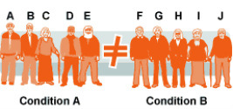
Matched pairs:

A matched pairs design is where pairs of participants are first matched on a key variable/s (i.e. IQ). Then one member is assigned to condition A and the other assigned to condition B.

Strengths: | Limitations:
- The issue of participant variables is greatly reduced.  - Order effects are totally avoided.  - Demand characteristics less likely. | - It is pretty much impossible to match people exactly on every characteristic; unless maybe they are identical twins – and even then, it is usually just matching physical characteristics.  - It is very time-consuming to find lots of people that match each other so closely.

Example of using matched pairs design in psychological research:

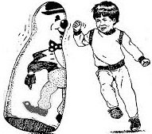
Bandura et al. investigated the effect of observing aggressive and non-aggressive role models on children’s behaviour. Would they imitate the aggression they had seen?

In order to control for naturally occurring aggression levels in the children (so it would not confound the DV) he got the children’s parents and teachers to rate their aggression on a 1-5 scale.

He then matched the children on their aggression levels so each condition had the same number of highly aggressive children (5), medium aggression (4-2) and non aggressive children (1).

Non Experimental Methods

Self-Report Techniques: Interviews
Although some interviews may be conducted over the phone, most involve a face-to-face interaction between interviewer and an interviewee. There are two broad types of interview: structured and unstructured.
Structured | Semi-structured | Unstructured
Structured interviews are made up of pre-determined  questions that are asked in a fixed order.  This is like a questionnaire but conducted face-to-face (or over the phone) in real time. | Many interviews are likely to fall somewhere between structured and unstructured.  There is a list of questions prepared in advance, but interviewers can follow up answers (like a job interview). | An unstructured interview is a lot like a conversation.  There are no set questions, but there is an aim that a certain topic will be discussed.  The interview will be free-flowing. The interviewee is encouraged to  expand on their answers.
Strengths & limitations of structured Interviews:-
- Easy to replicate due to their standardised format (increases reliability).
- However a problem is that it’s difficult for interviewers to deviate from the topic or for interviewees to expand on their answers (lacks depth and therefore validity)
Strengths & limitations of unstructured interviews:-
- Much more flexible; an interviewer can follow up on points if and when they arise gaining more insight and understanding (increase validity).
- However, trying to analyse the data can be challenging often because open ended questions are used (qualitative data)
- There is always the risk of interviewees being untruthful for reasons of social desirability.
Self -Report techniques: Questionnaires

These involve a pre-set list of questions (or items) to which the participant responds through written answers. These are used to assess a person’s thoughts and/or experiences.
A questionnaire may be used as part of an experiment to measure the DV. There are different styles of questions that can be designed. Open and closed questions.
Strengths – questionnaires are can be given to a large sample of people and so large amounts of data can be gathered relatively easily. They can also be done without the researcher being present i.e postal questionnaires.

However, limitations include respondents wanting to show themselves in a positive light (social desirability) rather than being truthful. Or respondents may show ‘reponse bias’ where they respond in a particular way, i.e always ticking ‘yes’ or answering ‘3’ on a scale of 5.

Open and closed questions:

Open questions do not have a fixed range of answers and respondents are free to answer in any way that they wish. Open questions tend to produce qualitative data (rich in depth, but difficult to analyse).

For example,
“Why do you enjoy the psychology A level course?”

Closed questions offer a fixed number of responses and produce numerical data by limiting the answers respondents can give. They produce quantitative data (easy to analyse, but lacks the depth associated with open questions).

For example,
‘Do you watch more than 10 hours per week of TV?’… ‘yes’ or ‘no’.

Or respondents may be asked to rate how often they watch soap operas on TV on a scale of 1-5.
1 2 3 4 5
1= never
3=sometimes
5= every day

Evaluation of open and closed questions:

Open questions

- Respondents can expand on their answers, which increases the amount of detailed information collected.
- Open questions can reveal unexpected answers; therefore researchers can gain new insight into people’s feelings and attitudes.
- They also provide qualitative data (non-numerical data) which although may be rich in information, it can be more difficult to summarise and/or detect patterns to draw conclusions.

Vs

Closed questions:

- They have a limited range of answers and produce quantitative data (numerical data). This means the answers are easier to analyse using descriptive statistics (mean, mode, graphical representation).

- However, respondents may be forced to select answers that don’t represent their true thoughts or behaviour, therefore the data collected may lack validity.

Designing questionnaires and interviews- What to avoid:
- Overuse of jargon (technical terms) that only those familiar with the field will understand
e.g. “do you agree that maternal deprivation in infanthood inevitably leads to affectionless psychopathy in later life?”

- Emotive language and leading questions (guiding the respondent to a particular response)
e.g. Fox hunting is a barbaric sport and any sane person would want it banned (emotive)
e.g. Is it not obvious that student fees should be abolished? (leading question)

- Double barrelled questions and double negatives
e.g. do you agree with this statement: Premier league footballers are overpaid and should give 20% of their wages to charity. (This contains two questions in one; respondents may agree with one half of the question but not the other and therefore would not know how to respond)

e.g. I am not unhappy in my job (agree/disagree)
This question is hard to decipher and could be written in a much clearer way!
Designing Interviews

Interviews are also a self-report method

They are more likely to collect qualitative data than questionnaires, but certain types of interview will lead to quantitative data being gathered.

A good interview will involve:-

An interview schedule – a list of questions the interviewer intends to cover. This should be standardised for each interviewee to reduce interviewer bias.

Recording – the interviewer may take notes throughout the interview (although this may interfere with listening skills). Alternatively, the interview may be audio recorded of videoed.

Effect of interviewer – one of the strengths of interviews over questionnaires is that the presence of the interviewer who is interested in the interviewee may increase the amount of information provided, this is because it allows a rapport to be built with the interviewee.
The interviewer needs to be careful with their non-verbal communication – not sitting with arms folded for example. Behaviour needs to be welcoming and encouraging i.e head nodding & leaning forward. A further consideration for the interviewer is listening skills – an experienced interviewer will know when and how to speak, i.e not interrupting or using negative language.

Ethical issues – Respondents should be reminded that their answers will be treated confidentially. This is especially important if the interview includes topics that may be personal or sensitive.
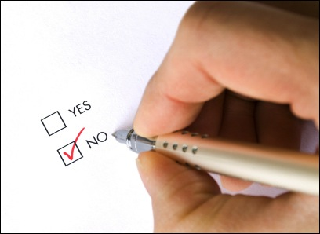
Designing Questionnaires

Questionnaires are a self-report method.

They are usually used to produce quantitative data for statistical analysis, but can also be used to collect qualitative data

Features of a good questionnaire:

- Clarity - Clear questions that are easy to understand for respondent (reader)
- Bias - Questions do not lead respondents to give a particular answer (e.g. ‘don’t you think violent films make children more aggressive?’)
- Assumptions - Avoids making assumptions about respondents, e.g. about sexuality
- Non-intrusive - Avoids questions that are too personal.
- Checked - Questionnaire is piloted to make sure questions are understood and interpreted correctly.
Examples of open questions:
- What factors contribute to making work stressful?
- How do you feel when stressed?
Examples of closed questions:
- Fixed choice option: respondent is given a list of possible options and they tick those that apply to them.
Which of the following makes you feel stressed?
- Noise at work
- Too much to do
- No job satisfaction
- Lack of control
- Workmates
- Likert scale: A likert scale is one in which the respondent indicates their agreement (or otherwise) with a statement using a scale of usually 5 points. It can range from strongly agree to strongly disagree.
Work is stressful:
- Strongly agree
- Agree
- Not sure
- Disagree
- Strongly disagree
- Rating scales: Rating scales ask respondents to identify a value that represents their feelings about a topic.
How much stress do you feel? Circle the number that best describes how you feel:
At work:
A lot of stress 5 4 3 2 1 No stress at all
At home:
A lot of stress 5 4 3 2 1 No stress at all

- Disagree
- Strongly disagree
- Strongly disagree

Non experimental methods: Observational Methods

Researchers might decide to conduct an observation to see for themselves how people behave rather than using an experiment or self-reports. There are two types of observational method to choose from:

Naturalistic and Controlled observations:

 | Naturalistic observation | Controlled observation
What is it? | This takes place in the participant’s natural environment. For example, it would not make sense to study how employees and managers from Primark behaved by dragging the workforce into an artificial lab setting. It would be much better to study their ‘interaction’ in their normal working environment. This means the researcher does not interfere in any way with what’s happening.  Be careful not to confuse a naturalistic observation with a natural experiment - they are different! In a natural experiment there is an IV, whereas in an observation there isn’t. | This takes place in a controlled environment provided by the researcher e.g. the strange situation.  In this set up the researcher can at least control for some variables, but it does reduce the ‘naturalness’ of the environment and behaviour being studied.
Strengths | Naturalistic observations provide a realistic picture of behaviour and therefore have high external validity (findings can be generalised to everyday life). Although this may be less so if participants are aware of being observed. | Controlled observations mean the researcher can focus on particular aspects of behaviour and also being controlled means extraneous variables are less of a problem and replication becomes easier.
Weaknesses | However, one of the issues is due to the lack of control there may be uncontrolled extraneous variables that may actually influence the behaviour observed.  Also, naturalistic observations tend to be one off situations and makes replication of the investigation challenging. | Making an environment more controlled can sometimes impact on how the participant’s behaviour. This may be less natural because of the environment.

Overt and Covert observations:

 | Overt observation | Covert observation
What is it? | In both naturalistic and controlled observations participants may be aware they are being observed, this is called an overt observation. Since this is likely to have an effect on the ‘naturalness’ of the participants’ behaviour, observers try to be as unobtrusive as possible. The participants would have given their informed consent beforehand. | Covert observations are those in which the participants are totally unaware they are the focus of a study and their behaviour is observed in secret, say from across the room or from a balcony. Participants are made aware after the study of what took place.  Observations can take place through a 2 way mirror (participant’s cannot see the observer)
Strengths | Overt observations have an ethical advantage to covert observations because participants are aware of what is going on and have given consent. | Covert observations have good internal validity because the participants are unaware of the observation, the behaviour will be natural (less likely to suffer from demand characteristics)
Weaknesses | However, the slight disadvantage is that having this awareness could mean participants behave differently to normal and behaviour is not as natural (weakens internal validity) | The down side of course is the ethics of these studies may be questioned, as people may not wish their behaviour to be studied without their initial consent.

Participant and Non-participant observations:

 | Participant observation | Non-participant observation
What is it? | Sometimes it may be necessary for the observer to become part of the group they’re studying, this is participant observation. For example, a researcher may join the workforce at Primark (as mentioned earlier) to get a first-hand account of relations between staff and managers. | In most cases, the observer is merely watching (or listening) to the behaviour of others and remains separate from the participants in the study. This is a non-participant observation.
Strengths | Participant observations can provide real insight into the participants being studied and this richness may not be gained in any other way (increases internal validity) | Non – participant observers are more likely to remain objective because they aren’t part of the group being studied.
Weaknesses | However, there is a danger the observer may identify too strongly with those they’re studying and as a result lose their objectivity. | But they may lose valuable insight into the participants because they are too removed from the people and behaviour (decreased validity).

Observational Design: How does a researcher actually plan an observational study?

Structured observations:
It is preferable to use these observations; they aim to be objective and rigorous.
The researcher uses a list of pre-determined list of behaviour categories and sampling methods.
Unstructured observations:
The researcher records all relevant behaviour, but has no system. They may simply write down everything they see!
…clearly there may be too much to record as well as recording behaviour that may not be that important.

Developing behavioural categories

For structured observations one of the hardest tasks before carrying it out is deciding how the behaviour should be categorised. The researcher needs to be very clear on exactly what behaviour they’re looking for. It is operationalising –breaking up behaviour in a set of components so it can be measured. For example, if the target behaviour was ‘affection’ the behavioural categories could be hugging, kissing, smiling, holding hands etc. The categories should be:-
- Objective – the researcher should not have to make guesses about behaviour. The categories must be observable.
- No waste basket – in other words all possible behaviours are covered and avoiding a ‘waste basket’ category, in which loads of different behaviour is thrown in because it’s unclear where the behaviour should be categorised.
- Independent of each other – categories should not overlap, meaning that the researcher has to mark two categories at one time.

Sampling Methods for observations:

With unstructured observations there is continuous recording of the behaviour in as much detail as possible and in many cases there would be far too much data to record. For complex behaviour, this may not be practical.

Structured observations have a systematic (a clear organised system) way of observing behaviour using sampling. There are two methods:-
- Event sampling – this involves counting the times a particular behaviour (event) occurs in an individual or target group. See example below.
- Time sampling – this method records behaviour within a particular time frame. For example noting what an individual is doing every 30 seconds, or some other time frame.

Example of event sampling…

What students do when their teacher leaves the room?

The record sheet below is used to record behaviour. The categories are across the top with space below to
Record the behaviour of a target student. A tally mark is placed each time one of the behaviours is observed.

Carries on working | Uses a mobile phone | Talks to another student | Listens to music | Leaves the room | Reads a magazine | Falls asleep | Eats
IIII | I | III | II |  |  |  | I

Evaluation of Observational methods:

Structured V Unstructured Design – structured observations are designed to use behavioural categories that make the recording of behaviour easier. The data is likely to produce quantitative data which means analysing and comparing the behaviour observed is straightforward.

By contrast unstructured observation design will tend to produce qualitative data, which may be harder to analyse. There is also a higher risk of ‘observer bias’ in unstructured design as behavioural categories aren’t used. Researchers may record behaviour that simply ‘catches their eye’ and could also miss important behaviours.

Behavioural Categories – Yes, having categories can make data collection easier, it adds structure and they’re objective, but…the categories need to be very clear avoiding the ‘waste basket’ category mentioned earlier.

Sampling – Event sampling is useful when the target behaviour or event happens infrequently and could be missed if time sampling was used however, if the event is too complex, the observer may overlook important details if using event sampling.
Time sampling is effective in reducing the number of observations that have to be made however those instances when behaviour is sampled might be unrepresentative of the observation as a whole.

Non experimental method: Case Studies

When a researcher conducts a case study, he or she gathers in-depth information on an individual, or small groups of individuals, using a variety of techniques. This can lead to greater internal validity due to the richness of the information gathered. The people being studied are normally pretty unique and are studied with the aim of answering difficult or important questions that cannot be investigated experimentally.
Examples include HM and Clive wearing (severe memory loss). When compiling a case study a psychologist can draw on a huge range of possible sources of information.

These might include:

Interviews with the subject | Results of experimental tasks carried out by the subject | School records and reports
Medical records | Physiological measures e.g. MRI scans, EEG traces | Tests of personality
Interviews with teachers/managers | Observations of the subject | Diaries, letters or other biographical information
Attitude tests | Tests of clinical symptoms (e.g. depression) | Interviews with colleagues/co-workers
Tests of intelligence | Interviews with parents/family members | Employment records

Advantages of case studies
- Rich in detail- provide great depth and understanding about individuals.
- The only possible method to use- case studies allow psychologists to study unique behaviours or experiences that could not have been studied any other way. The method also allows ‘sensitive’ areas to be explored, where other methods would be unethical, like the effects of sexual abuse.
- Useful for theory contradiction- just one case study can contradict a theory.

Disadvantages of case studies
- Not representative- as no two case studies are alike, results cannot be generalised to others.
- Researcher bias- researchers conducting case studies may be biased in their interpretations or method of reporting, making findings suspect.
- Reliance on memory- case studies often depend on participants having full and accurate memories.

Non experimental method: Correlation

Strictly speaking a correlation isn’t a research method as such, but a way Psychologists can measure the strength between two or more co-variables (things that are measured).
For example, if the amount of aggressive games children play can have an effect on the amount of aggression they show in the playground. (The two co-variables here are aggressive games and aggression displayed).

Types of correlation:

Correlations are plotted on scattergrams (shown below). One co-variable is on the x-axis (horizontal) and the other on the y-axis (vertical). Each point or cross on the graph is the x and y position of each co-variable.

If the crosses on a scattergram are going in this direction, then the relationship is negative
If the crosses on a scattergram are going in this direction, then the relationship is positive
X
X
X
X
X
Line of best fit
X
X
X
X
X
X
X
X
X

The closer the crosses are clustered around the line of best fit, the stronger the correlation

A negative correlation – where one co-variable increases and the other decreases. For example the temperature and number of gloves sold. The higher the temperature, the less number of gloves will be sold.
A positive correlation – where one co-variable increases and so does the other. For example the number of people in a room and noise are positively correlated. The more people in a room, the more noisy it becomes.

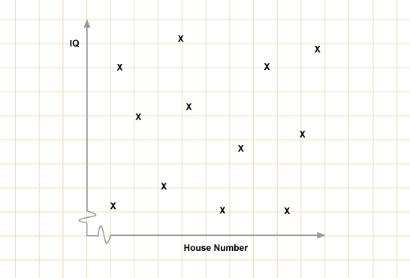
No Correlation

Of course, there may be variables that have no relationship, in which the dots/crosses will be scattered all over the graph. For example a person’s IQ (intelligence) and their house number. This is a zero correlation.

Correlational hypotheses:
Correlations also have hypotheses. Correlational hypotheses predict a relationship between two variables not a difference (like in experiments), and therefore they are worded differently to experimental hypotheses. A directional hypothesis for a correlation states whether the relationship will be a positive or a negative correlation. A non-directional hypothesis simply states that there will be a correlation.

For Example:

Directional correlational hypothesis
There will be a significant positive correlation between temperature and ice-cream sales or

There will be a significant negative correlation between temperature and scarf sales.

Non-directional correlational hypothesis
There will be significant correlation between average time spent reading per week and scores on an I.Q. test.

Correlation co-efficients

Correlations are designed to investigate the strength and direction of a relationship between two variables. The strength of the correlation is expressed by the correlation coefficient.

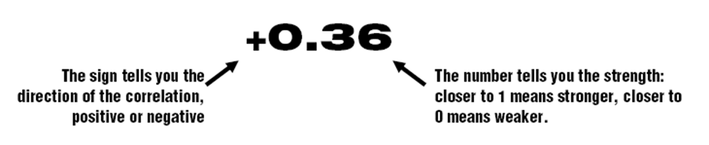
The correlation coefficient is always a figure between +1 and -1 where +1 represents a perfect positive correlation and -1 represents a perfect negative correlation and 0 means there is no correlation.

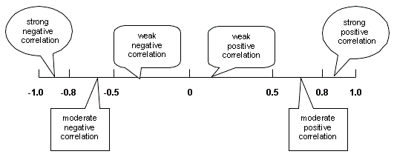

Perfect Positive
Perfect Negative

No correlation

Therefore The closer the correlation coefficient is to 0, the weaker the correlation
The closer the correlation coefficient is to 1 (or -1), the stronger the correlation
Examples…

Strong positive Moderate positive Weak negative Strong negative

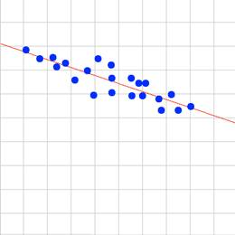
+0.8 +0.5 -0.40 -0.95
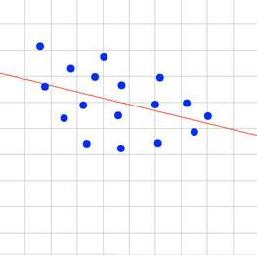
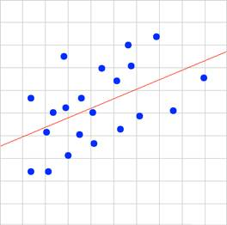
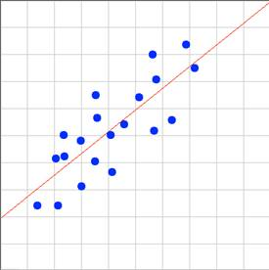

Evaluation of correlation:

Strengths of correlation
- Correlations are useful as a tool of research as they provide a strength and direction of a relationship between variables and can be used as a starting point to assess the relationship between variables before committing to an experimental study.

- They allow researchers to look at the relationship between variables that you would not be able to experimental investigate e.g. obesity and junk food consumption.

- They are also quite quick and economical to carry out because there is no need for a controlled environment and no manipulation of variables is required, so they are less time consuming than the planning and execution of setting up an experiment.

- They can also use secondary data (data collected by others e.g. government statistics), which means they are less time consuming.

Limitations of correlation
- Correlations don’t provide a cause and effect relationship; we cannot conclude that one variable is causing the other to change. This can sometimes lead to correlations being misinterpreted or misused.

For example, does increased levels of reciprocity lead to a better quality of attachment OR does a better quality of attachment lead to increased levels of reciprocity?

- Although correlations can tell us the strength and direction of variables, they cannot tell us why the variables are related.

- It may also be the case that another untested variable is causing the relationship between the two co-variables. This is known as the third variable problem.

For example, there may be a relationship between being raised in a single-parent family and the increased likelihood of being involved in crime. ‘Third variables’ at work here might be factors such as the fact that children from single parent families tend to be less well-off so this might explain the link between one=parent families and crime.
Content analysis
Content analysis is a method used to analyse qualitative data (non-numerical data). In its most common form it is a technique that allows a researcher to take qualitative data and to transform it into quantitative data (numerical data).
- The technique can be used for data in many different formats, for example interview transcripts, TV programmes or films, written communication (texts, emails) audio recordings.
The researcher conducting a content analysis will use ‘coding units’ in their work. These units vary widely depending on the data used, but an example would be the number of positive or negative words used by a mother to describe her child’s behaviour or the number of swear words in a film. The aim of content analysis is to summarise and describe the data in a systematic way so overall conclusions can be drawn.
The procedure for a content analysis is shown below:
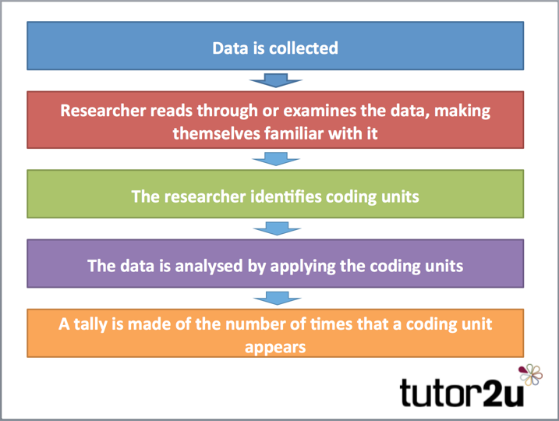

Coding and quantitative data
After data has been collected and the researcher has familiarised themselves with the content then coding will occur. The researcher will identify coding units of interest and use these as a basis for categorising the data. This needs to be done because often the data set to be analysed can be extremely large (e.g. transcripts of 40 long interviews).
This may involve counting the number of times a particular word or phrase appears in the text to produce a form of quantitative data. For example, newspaper reports may be analysed for the number of times derogatory terms for people with mental illness are used, such as ‘crazy’ or ‘mad’.
Thematic analysis and qualitative data
Thematic analysis is a qualitative data analysis method that involves reading through a data set (such as transcripts from in depth interviews or focus groups), and identifying patterns in meaning across the data.
So the researcher starts off with a source of qualitative data to generate more meaningful qualitative data.
This is how it works:

Familiarize yourself with the data - Get familiar with the data. If your data is in the form of audio files, transcribe them yourself or get them transcribed (see how to transcribe interviews). Read through the transcripts and actively observe meanings and patterns that appear across your data set.

2. Create your initial codes
Now that you’re familiar with the data, create a set of initial codes that represent the meanings and patterns you saw in the data. Read through your data again, and identify interesting excerpts.

3. Collate codes with supporting data
Now, group together all the excerpts associated with a particular code.

4. Group codes into themes
Now that you have a set of initial codes, sort the codes into potential themes. See how various codes can be combined, and see if there are themes that can be made into sub-themes.

5. Review and revise themes
Now that you have your initial set of themes, review and revise your themes. Ensure that each theme has enough data to support them and is distinct.

6. Write your narrative
Writing the narrative is the final step to tell the story of your data. You should have fully thought out themes, and now it’s your chance to communicate to your readers about the validity or your analysis. Make sure that your narrative tells a coherent story about your data, and choose vivid quotes from your data that help back up your points.

Evaluation of content and thematic analsysis
Strengths | - High in external validity because the data is obtained from real life experience e.g. journal entry.  - Content analysis is flexible in the sense that it may produce quan. and qual. data depending on the aims of the study.
Limitations | - Communication that people produce is normally analysed outside of the context within which it occurred. This is a limitation as the researcher may attribute opinions and motivations to the speaker or writer that were not originally intended.  - Can be difficult to decide on appropriate categories/codes/themes and time-consuming to carry out  - It may suffer from a lack of objectivity, especially when more descriptive forms of thematic analysis are employed.

Sampling:

Now, we have considered the various research methods used in Psychology, how do researchers get people to study in the first place? This occurs through sampling.

Key Concepts and terms:

The population refers to the large group of individuals that a particular researcher may be interested in studying, for example students in the South East, children under 10 with autism, men with an eating disorder. This is a target population because it’s a subset of the general population. Clearly, this is too large to study, therefore the researcher selects a sample of this target population.

A sample is a group of people who take part in the research and is taken from the target population. Researchers aim to obtain a representative sample so that the findings can be generalised. There are a few sampling techniques that can be used to obtain a representative sample.

Bias – In the context of sampling, bias can occur if certain groups may be over or under-represented within the sample selected. For example, there could be too many younger people in a sample. This limits the extent to which generalisations can be made to the target population.

Generalisation – As touched on above, this is the extent to which the findings and conclusions from a study can be applied to the population. This is made possible if the sample of participants is representative of the population

Sampling techniques:

Opportunity Sampling

Opportunity sampling - is where a researcher decides to select anyone who is available and willing to participate in their study. Students are often used in psychological research for this reason.

Random sample Systematic sample
Opportunity sampling evaluation

Strengths
- This method is convenient as it saves time, effort and is less costly

Limitations
- The sample is likely to be unrepresentative of the target population as it’s drawn from a specific area such as one street in one town.
- The researcher has complete control over the selection of participants, they may simply avoid people they don’t like the look of (researcher bias)

A systematic sample is a form of sampling when every nth member of the target population is selected, for example, every 5th house on a street or every 3rd pupil on a school register.
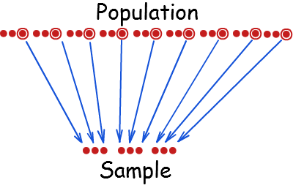
A sampling frame is produced, which is a list of people in the target population organised into, for instance, alphabetical order. The researcher then works through selecting every 5th, 3rd, 9th person etc.

A random sample is a form of sampling in which all members of the target poulation have an equalchance of being selected.
To select a random sample firstly, a complete list of all members of the target population is obtained.
Secondly, all the names are assigned a number.
Thirdly, the sample is generated through the use of some lottery method (computer-based randomiser or picking numbers from a hat/container). 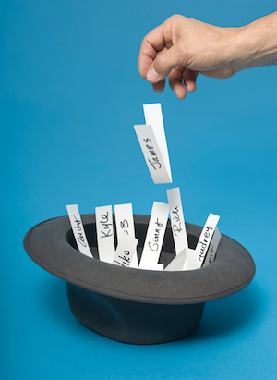

Evaluation:

 | Random | Systematic
Strengths | - It is free from researcher bias. The researcher has no influence on who is selected and therefore selecting people who they think may support their hypothesis. | - This sampling method avoids researcher bias. Once the system for selection has been established the researcher has no influence over who is chosen  - It is usually fairly representative.
Limitations | - Very difficult and time-consuming to conduct. A complete list of the target population may be extremely difficult to obtain.  - Participants selected may refuse to take part (resulting in further bias). | - The process of selection can interact with hidden ‘traits’ within the population. If the sampling technique coincides with the frequency of the trait, the sampling technique is neither random, nor representative. For example, if every fourth property in a street is a flat occupied by a young person, then selecting every fourth property will not provide a representative sample.

Stratified sampling
An example of stratified sampling…
Let’s talk TV choices. In Manchester 40% of people watch X Factor, 40% prefer Britain’s got Talent, 15% watch The Voice and 5% watch Strictly Ballroom.

In a stratified sample of 20 participants there would be 8 people who like X factor, 8 for Britain’s got Talent, 3 Voice fans and 1 solitary Strictly fan.

Each of these would be randomly selected from the larger group of each TV choice.

A stratified sample is a sophisticated form of sampling. From the wider population a sub-group is created (strata) based on age, social class etc. Then the population is randomly sampled within each strata.
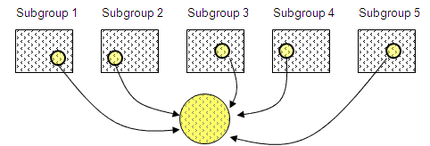

To carry out a stratified sample the researcher first identifies the different strata that make up the population.
The proportions needed for the sample to be representative are worked out.
Finally, the participants that make up each strata are selected randomly (see how this is done for random sampling)
Stratified sampling Evaluation

Strengths
- Again, this technique avoids researcher bias. Once the target population has been sub-divided into strata, the participants that make up the numbers are randomly selected.
- This method produces a representative sample because it’s designed to accurately reflect the population, which means generalisation of findings becomes possible.

Limitations
- Stratified samples require a detailed knowledge of the population characteristics, which may not be available.
- It can be very time-consuming dividing a sample into strata and then randomly selecting from each.

Volunteer sampling evaluation

Strengths
- Creating the sample requires little effort from the researchers (other than producing an advert) as participants volunteer themselves.

Limitation
- The sample will be bias and unrepresentative as volunteers tend to be a certain ‘type’ of person. This makes results difficult to generalise to a target population.
- Volunteers are eager to please, which increases the chances of demand characteristics, for example participants giving the answer they think is required.

Volunteer sampling – or self-selected sample is where participants select themselves to be a part of the study.
A researcher may place an advert online/newspaper/noticeboard for example, and people respond wanting to take part in the study.

Pilot studies

A pilot study is a small-scale trial run of the actual investigation. It takes place before the real investigation is conducted. It’s like a ‘dummy run’ and its aim is to check that the procedures and materials work, and the instructions to participants are clear.
This allows the researcher to make any changes if necessary, before the real investigation is carried out.

Pilot studies are not just restricted to experiments, they can be used for self-reports, like questionnaires or interviews; in this case it may be useful to try out questions in advance and remove and replace words or questions that may be confusing. Also, with observational studies, a pilot study would be a good way to check the behavioural categories are effective before the real observation takes place.

In summary, a pilot study allows the researcher to identify any potential issues and to modify the design or procedure, saving time and money in the long run.

NB- the purpose of a pilot study is not to check if the researcher is going to get the results they want!

Ethical issues and ways of dealing with them

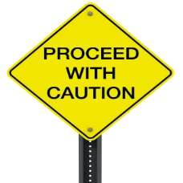
Ethical issues arise in Psychology when conflicts arise between the rights of participants in research studies and the goals of researchers to produce valid data. The BPS code of ethics (British Psychological Society) is a legal document instructing Psychologists in the UK about what behaviour is and is not acceptable when dealing with participants.

Major ethical issues are:-

Deception | Informed consent | Protection from harm | Privacy  (confidentiality) | Right to withdraw
Deception means deliberately misleading or withholding information from participants. Despite this, there are occasions when deception can be justified if it doesn’t cause undue distress.  For example, Milgram deceived his participants by telling them it was a study on ‘learning’ not obedience. | Participants should be aware of what they’re doing. Informed consent is making participants aware of the aim of the research, the procedures and their rights. They can make an informed decision on whether they want to take part.  For example, Loftus didn’t tell participants the true aim of the study (to investigate the effect of anxiety on EWT) | Participants should not be placed in any physical or psychological risk. (i.e. feeling embarrassed, inadequate or placed under undue stress).  For example, participants in Zimbardo’s study were subject to psychological harm. The study was stopped after 8 days because of this. | Participant’s data should not be disclosed to anyone unless agreed in advance. Numbers should be used instead of names. Participants shouldn’t be able to identify themselves either.  For example, important case studies in memory are often referred to by initials HM, KF. | Participants should be aware they can leave a study at any time, and even withdraw their data after the study is finished.  For example, in Milgram’s study participants were made aware that they could leave the study at any time but due to the nature of the research participants felt they did not have this right.

Ways of dealing with ethical issues:

BPS code of conduct: The British Psychological Society (BPS) as mentioned above has its own ethical guidelines. Psychologists have a professional duty to observe these guidelines. The guidelines are closely matched to the ethical issues above and attempt to ensure all participants are treated with respect and consideration during a piece of research.

Dealing with…

- Informed Consent – Participants should be issued with a consent letter/form detailing the relevant information that may affect their decision to take part.
Below is an example of a consent form (you could be asked to write a consent form in the exam so take note of the details it includes!)
Informed Consent Form
The Department of Psychology at Wagner College supports the practice of protection of human participants in research. The following will provide you with information about the experiment that will help you in deciding whether or not you wish to participate. If you agree to participate, please be aware that you are free to withdraw at any point throughout the duration of the experiment without any penalty [Note: the penalty statement is only appropriate for students].

In this study we will ask you to __________________*. If you have any [insert reason why they should not participate if applicable], please inform the experimenter and the study will end now. All information you provide will remain confidential and will not be associated with your name. If for any reason during this study you do not feel comfortable, you may leave the laboratory and receive credit for the time you participated and your information will be discarded. Your participation in this study will require approximately _____ minutes. When this study is complete you will be provided with the results of the experiment if you request them, and you will be free to ask any questions.

If you have any further questions concerning this study please feel free to contact us through phone or email: RESEARCHER NAME at NAME@wagner.edu.
Please indicate with your signature on the space below that you understand your rights and agree to participate in the experiment.
Your participation is solicited, yet strictly voluntary. All information will be kept confidential and your name will not be associated with any research findings.
______________________________ _______________________________
Signature of Participant NAME, Investigator
______________________________
Print Name
-------------------------------------
PLEASE NOTE: If your participants cannot legally give consent (those under 18, for example), the form must be addressed to the parent or guardian.
*If you are asking the participant to read something, view something, reveal personal information, eat something, taste/smell something, you must inform them. You must warn participants if it is possible something you ask them to read or view may be offensive or explicit. Please describe how long (approximately) the procedure will take. Potential participants must be able to make an informed consent to participate!

Assuming the participant agrees, then the consent form is signed. For investigations involving children under 16, a signature of parental consent is required.

However, if you cannot get informed consent from your participants- there are alternative ways of getting consent…
Presumptive consent – rather than getting consent from the participants themselves, a similar group of people are asked if the study is acceptable. If this group agree, then consent of the original participants is ‘presumed’.
Prior general consent – Participants give their permission to take part in a number of different studies- including one that will involve deception. By consenting, participants are effectively consenting to be deceived.
Retrospective consent – This involves asking participants for consent after they have participated in the study (debriefing). They may not have been aware of their participation. However, they may not consent and have already taken part.

Ways of dealing with:

- Deception – At the end of a study, participants should be given a full debrief. This means they should be told the true aims of the research, the various conditions of the research, and what their data will be used for. They should be told they can withhold their data if they wish.

- Privacy - If personal details are held these must be protected. However, it’s more usual for researchers to use numbers rather than names.

Qualitative and Quantitative data

When a psychologist carries out research data is collected. This could be words, numbers, images. Once conext (meaning) is added then data becomes ‘information’. Data analysis is turning data into information. But first... there are two main types of data that could be collected.

- Qualitative data – is expressed in words, rather than numbers or statistics. It may take the form of a written description of the thoughts, feelings and opinions of participants. For example, a transcript from an interview, an extract from a diary or notes.
- Quantitative data – This is data expressed numerically. This form of data usually gathers numerical data such as individual scores from participants such as the number of words a person was able to recall in a memory experiment. Data is open to being analysed statistically and can be expressed using graphs, charts etc.

Is either type of data better?

Not really, it depends upon the purpose and aims of research and many researchers combine both in their research. For example, a researcher collecting quantitative data as part of an experiment may often interview participants as a way of gaining more qualitative insight into their experience of the investigation. Furthermore, there are a number of ways in which qualitative data can be converted to numerical data.

Evaluation of Qualitative and Quantitative data

 | Qualitative | Quantitative
Strengths | It offers the researcher more richness and detail which can provide unexpected insights upon behaviour. This is due to the fact the participants have more licence to develop their thoughts, feelings and opinions on a given subject. The data does have more internal validity. | As the data is numerical, it’s objective and less subject to bias. It is also far easier to analyse and draw conclusions.
Limitations | However, qualitative data can be difficult to analyse, it does not lend itself to being summarised statistically so that patterns and comparisons can be drawn.  A consequence of this is that conclusions may rely on subjective interpretations of the researcher which may be subject to bias. | However, it is much narrower in scope and meaning than qualitative data and therefore not fully representative of real-life.

Primary and secondary data

Qualitative and Quantitative data is the type of data a researcher can collect.
Primary and secondary refer to how the data has been obtained. Both primary and secondary data can be qualitative and/or quantitative.

Primary data

This is data that has been gained directly (first-hand) from the participants, it would be specifically related to the aims and/or hypothesis of the study. The data conducted from participants doing an experiment, questionnaire, interview or observation would be classed as primary.

Secondary data

This is data that has been collected by someone other than the person conducting the study. This may be data that already exists before the psychologist begins their research.
Examples would be data in journal articles, books, websites, government statistics etc. A piece or research that uses secondary data is a Meta-analysis.

Meta-analysis

Following discussing primary and secondary data, this is a good time to consider Meta-analysis. It’s a type of research method that uses secondary data. What happens is the researcher uses the data from a large number of studies, which have involved the same research questions and methods. The results of all these studies are analysed to give an overview and conclusion. For example, Van Ijzendoom and krooneberg (cultural variations in attachment).

The researcher(s) may simply discuss the findings/conclusions - which is a qualitative analysis. Or they may perform a statistical analysis on the combined data. This may involve calculating the effect size (the DV of a meta-analysis).
What is effect size?

Köhnken (1999) conducted a meta-analysis of 53 studies related to the cognitive interview. They were exploring the effectiveness of the cognitive interview compared to standard interview techniques. The effect-size was 34%. This means that of all the studies the cognitive interview technique improved recall by 34%, when compared to the standard interview technique.

So, effect size gives is an overall statistical measure of the difference or relationship between variables across a number of studies.

Evaluation of primary and secondary data

 | Primary | Secondary
Strengths | - The researcher has control of the data in that it can be designed to fit the aims and hypothesis of the study | - Inexpensive and easily accessed.  - The data has probably already been statistically tested and peer reviewed.
Limitations | - To produce primary data requires time, effort and can be expensive. Conducting an experiment, for instance requires considerable planning, preparation and resources, considering secondary data which can be accessed within a matter of minutes. | - The content of the data may not exactly fit the needs of the study. It may be incomplete or out-dated and therefore not match the researcher’s objectives.  - There may be substantial variation in the quality and accuracy of secondary data.

The role of Peer Review

Psychology is a science. The aim of science is to produce a body of knowledge through conducting research. The findings (results) of research is publicised through conferences, textbooks, academic journals (such as the Journal of Experimental Psychology).

However, before a piece of research can become a part of a journal it must be rigorously checked. This is peer review.

The research is scrutinised by a small group of usually two or three experts (peers) in the particular field. These experts should be objective and unknown to the author. This helps any research intended for publication is of high quality.

The main aims of peer review:
- Allocation of research funding – Research is paid for by various charitable bodies. The overall budget for science for 2015-2016 was set at £5.8 billion. The organisations spending this money obviously have a duty to spend it responsibly. Therefore, public bodies like the Medical Council require reviews to enable them to decide which research is likely to be worthwhile.

- Assess the quality & relevance of research – All elements of the research is assessed for quality and accuracy: if the hypotheses, research method, statistics and conclusions are appropriate and relevant.

- Suggesting improvements – Peer reviewers may suggest minor changes to the work to therefore improve the report that’s been submitted. In extreme circumstances they may conclude the work is inappropriate for publication and should be withdrawn.

- Assessing the research rating of University Departments – The funding Universities get depends upon the good rating they receive from the peer review process.
Evaluation of peer review

While the benefits of peer review are clear, essentially to establish validity and accuracy in research, there are a number of criticisms towards this process.

- Finding an expert – It isn’t always possible to find an appropriate expert to review a research proposal (research to be done) or report (research already done).

- Anonymity – The process can be done so that the ‘peer’ remains anonymous (unknown), so that an honest and objective appraisal can be achieved. However, it’s not unheard of where a minority or reviewers may use their anonymity as a way of criticising rival researchers who may have crossed them in the past! Nowadays, peer reviewing may be ‘open’ which is where both the author and reviewer know each other’s identity.

- Publication bias – The editors of journals want to publish significant ‘headline grabbling’ findings to increase the circulation of their publication. This means they may prefer to publish research with significant (positive) results. This could mean research that doesn’t reach these criteria could be ignored. – This creates a false impression of the current state of Psychology if editors are being selective/bias in what they publish.

- Burying ground breaking research – The peer review process may suppress ground breaking research that may contradict the views of the reviewer. Established scientists are the ones likely to be chosen as reviewers, but this may mean results of research that coincide with current opinion are more likely to be passed than new, fresh and innovative research that poses a challenge to the established order.

Descriptive Statistics:
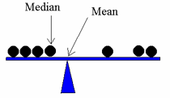
There are numerous ways of summarising and analysing quantitative data in order to draw meaningful conclusions. These are known as descriptive statistics - which include measures of central tendency, measures of dispersion and also graphs.

Measures of central tendency
Measures of central tendency are ‘averages’ which gives us information about the most typical values in a set of data. The three to consider are the mean, the median and the mode.
Mean: This is calculated by adding all the scores in a data set together and dividing by the number of scores.

So, in a data set with the following:-

5, 7, 7, 9, 10, 11, 12, 14, 15, 17

The total is 107 divided by the number of scores (10) which gives a mean value of 10.7

Median: This is calculated by putting all the scores in a data set in order, and identifying the score in the middle. In an even numbered data set, the two middle scores are added together and divided by 2 to find the median.

In the above data set: 5, 7, 7, 9, 10, 11, 12, 14, 15, 17

They are already arranged in order, they are an even set, the two middle scores are 10 and 11, so the median is 10.5 (21/2).

Mode: This is the most commonly occurring score. In some data sets, there may be more than one mode (bi-modal). In the above set of data the modal value is 7.

NB You may be asked to calculate any of the measures of central tendency- so make sure your maths skills are up to date!

Evaluating Measures of Central Tendency
 | Strengths | Limitations
MEAN | - The most sensitive as it includes all the scores/values in the data set within the calculation.  - Due to the above point, it’s more representative of set of scores. | - Easily distorted by extreme values
MEDIAN | - Not affected by extreme scores  - Once arranged in order the median is easy to calculate. | - It is not as sensitive as the mean, as not all scores are included. In final calculation.
MODE | - Very easy to calculate  - Unaffected by extreme values | - Not very useful if there are several modes.

Measures of dispersion

When describing data, as well as looking at the ‘averages’ of a set of data, we can also assess how ‘spread out’ the data is. This just means how far scores vary and differ from one another. The two we will consider are the range and standard deviation.

The range:

This is an incredibly easy measure of dispersion to calculate. It involves subtracting the lowest score from the highest score.

For the following:- 5, 7, 7, 9, 10, 11, 12, 14, 15, 17

The range would be (17 – 5) = 12

- It is most useful when assessing how representative the median is a typical score.
- This is because the median only takes into account the one score in the middle of the data set.
- The higher the range, the less representative the median is because it would indicate that the scores are spread widely from that figure.

The standard deviation:

This is a sophisticated measure of dispersion. It is a single value that tells us how far all scores deviate (move away from) the mean.

A high standard deviation - suggests a greater spread of scores around the mean. For example, in an experiment looking at the amount of words recalled after an interference task, a large standard deviation would suggest that not all participants were affected by the IV in the same way, because the data is widely spread.

A low standard deviation - suggests the scores are clustered close to the mean. We could imply from this that participants responded in a similar way. This would indicate that the mean is more representative as a typical score. This is because a low score indicates a low average distance between each score and the mean.

A quick example…

The table below shows the summary of an experiment that was comparing the number of words recalled when participants learned in silence to being learned whilst music was playing in the background.
Study tip:

You will be pleased to hear you don’t have to calculate the standard deviation in the exam! It’s a complicated calculation to carry out ‘by hand’ but quite straightforward using a calculator.

However, you will have to be able to interpret what the standard deviation scores tell us about a data set.
Do they show a greater spread of scores (more variation) or a lesser spread of scores (less variation)?

 | Condition A  (learned in silence) | Condition B  (learned with music playing)
Mean number of words recalled | 21.2 | 14.6
Standard deviation | 1.1 | 4.6

The standard deviations for both conditions are different. The low value of 1.1 in condition A suggests that the data for the participants are quite tightly clustered around the mean and that the participants responded in a similar way. However, in condition B with a value of 4.6 the scores are more spread out around the mean score (average) suggesting that not all participants responded in the same way, some were probably affected by the noise in the background interfering with their recall, whereas for others it made no difference. The scores are more varied.

Another exam question example…..
When the researchers looked at the data collected more closely they notice possible gender differences in the results

What do the mean and standard deviation values suggest about the male and female performances in the investigation? [4 marks]

The mean scores show that males may have much better map reading abilities than females as the mean for male participants is much (10.15) higher than it is for female participants- 3 times larger.

However, the standard deviations for the male and female scores are similarly spread out (dispersed around the mean) suggesting that in both groups, the scores were reasonably close together with SD= 2.7 (males) and 2.22 (females).

Evaluation of Measures of Dispersion
 | Strengths | Limitations
Range | - Very easy to calculate | - It only takes into account the two most extreme values (may be unrepresentative of the whole data set).
Standard deviation | - A more precise measure of dispersion than the range as it includes all values in the final calculation. | - Like the mean, it can be affected by a single extreme value  - By hand it can be complicated to carry out.
Presentation and display of quantitative data

There are various ways of representing data. Let’s have a look at a few of the most common.

Tables:

The table below shows the mean number of words spoken in 5 minutes after participants take part in two conditions; drinking an energy drink and drinking water.

 | Energy drink condition | Water condition
Mean | 119 | 96
Standard deviation | 53.8 | 35.8

Tables are usually accompanied with a summary paragraph explaining the results…

The mean values seem to suggest that there were more words spoken in the 5 minutes following consumption of the energy drink, than from drinking water. This tells us that drinking an energy drink makes people more talkative than drinking water.

The standard deviation is higher in the energy drink condition suggesting that there was a larger spread of scores. This suggests that not all participants were equally affected by the energy drink. In the water group, scores were close to the mean to a greater degree.

Bar Charts

Data can be represented graphically so the difference in mean values can be easily seen. Bar charts are used when data is divided into categories, known as discrete data. Bar charts are not appropriate for continuous data

For example:

 | EastEnders | Casualty | Peak Practice | The Bill
Mean number of viewers (millions) | 15 | 10 | 5 | 7

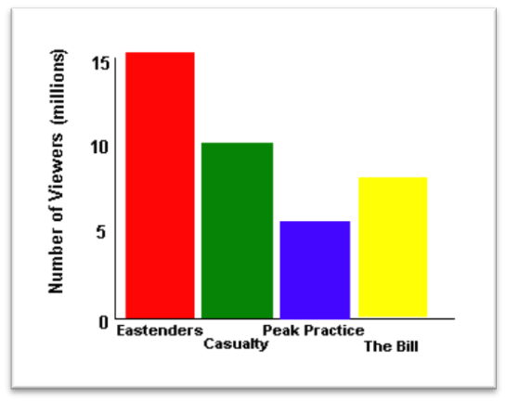
Bar chart showing number of people watching each television programme
Point to remember with a bar chart…
- Chart should be titled
- Categories plotted on x axis (horizontal)
- Total number of each category plotted on y axis (vertical)
- Axes labelled
- Bars are separate, to show display of discrete categories

Scattergrams

These were mentioned earlier in this pack when we considered correlations. The scattergram below is displaying the relationship between the average number of hours children watch TV and the amount of aggressive behaviour they show.
- They are only used to graphically display a relationship between 2 co-variables (a correlation)

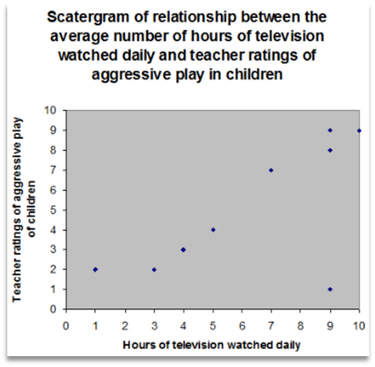
Points to remember about scattergrams…
- Should be titled
- One variable is plotted on the x axis, the other on the y axis (it doesn’t matter which goes where)
- Each axis should be labelled
- For each pair of scores a dot/cross is placed on the graph where the two scores meet

Histograms
In a histogram the bars touch which shows the data to be continuous, rather than discrete (bar chart).
Points to remember about histograms…
- The x axis is made up of equal sized intervals of a single category
- The y axis represents the frequency (number of people scoring a certain amount) within each interval.
- If there was a zero frequency for one of the intervals, there would be no bar
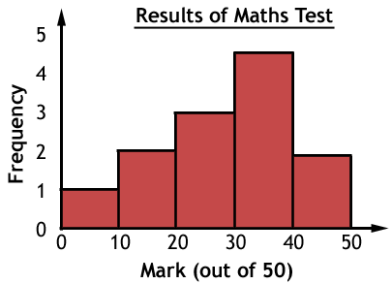

Distributions

Another way data can be expressed is through distribution curves. The two main types you need to know are a normal distribution and skewed distribution.

Normal distribution

If you measured the height of all the students at BHASVIC, the frequency of these measurements would form a bell-shaped curve. This is called a normal distribution curve.
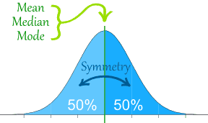
- Within a normal distribution curve, shown on the left, most of the students measured will be located in the middle area of the curve, with very few people at the extreme ends.

- The mean, median and mode all occupy the same mid-point of the curve.

- The ‘tails’ of the curve extend outwards and technically never touch the x axis (and therefore never reach zero)

Normal distribution curves have important statistical facts related to them. As seen in the curve below:-

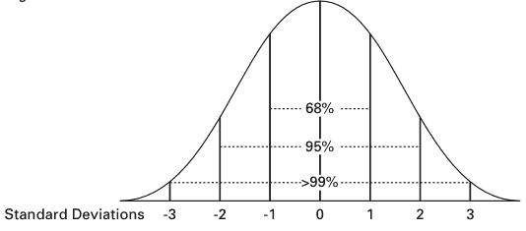
95% (95.44%) of the population fall between two standard deviations above and below the mean value

68% (68.26%) of the population fall between one standard deviation above and one standard deviation below the mean value (the middle section of the curve).

99% (99.73%) of the population fall between three standard deviations above and below the mean value

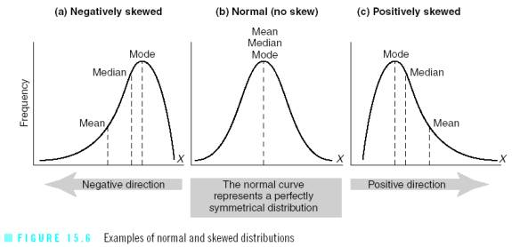
Skewed distributions (skewed means a lack of symmetry)

Not all distributions form such a symmetrical pattern. Some data from psychological scales for example, may produce a skewed distribution, in other words it appears to lean to the left or the right. Outliers (extreme ‘freak’ scores) can cause skewed distributions.

Positive skew

Shown above in (c) is a type of distribution in which the long tail is on the positive (right) side of the peak, and most of the distribution is concentrated on the left.
For example, if students were given a very difficult test in which most achieved very low marks. Only a handful got very high marks. This would produce a positive skew.

The measures of central tendency would be influenced in this situation.
- The mode, the most commonly occurring score remains at the highest point of the peak
- the median comes next
- the mean (remember how extreme scores can affect it) has been dragged across to the right. The few very high scores have had the effect of pulling the mean to the right.
- The median and mode (not affected by other scores) remain less influenced.

Negative skew

Shown above in (a) is where the opposite occurs. It’s a type of distribution in which the long tail is on the negative (left) side of the peak and most of the distribution is concentrated on the right.

For example, a very easy test would produce a distribution where the bulk of the scores are concentrated on the right- most people score very highly and only a few scored low marks.
- The mode (most commonly occurring score) remains at the highest point of the peak.
- The median will be in the middle
- The mean would be pulled to the left this time (due to lower scorers being in the minority),

Mathematical Content

Now we get to the part in research methods where some of you will be pleased of the maths component and some of you would rather run to the hills and hide! At least 10% of the marks in assessments will require some mathematical skills. Nothing to be scared of, just take your time with it.

Calculation of percentages

The table below shows the results of a repeating measures design in which participants taking part drank an energy drink and water and the amount of words spoken in each condition was recorded i.e. Participant 1, said 110 words after drinking the energy drink and 112 words after drinking water.

 | P1 | P2 | P3 | P4 | P5 | P6 | P7 | P8 | P9 | P10
Energy  condition | 110 | 59 | 206 | 89 | 76 | 141 | 152 | 98 | 198 | 57
Water condition | 122 | 45 | 135 | 90 | 42 | 87 | 131 | 113 | 129 | 62

Question: Work out what percentage of participants spoke more in the energy condition than in the water condition?

Answer: First, we can see there were 6 participants whose word score was higher in the energy drink condition than the water condition out of a total of 10 participants.

To calculate the percentage we use the formula:

Number of participants who spoke more after the energy drink x 100 = 6 x 100 = 60%
Total number of participants 10

Converting a percentage to a decimal

This is nice and easy, to convert a percentage to a decimal,
Step 1. Remove the % sign
Step 2. Move the decimal point two places to the left.

For example: 37% is 37.0 then move the decimal point two places to the left which is 0.37

The experiment above: 60% is 60.0, move the decimal point two places to the left = 0.60 (0.6)

Converting a decimal to a fraction

First you need to work out the number of decimal places in your number. For example, 0.49 has two decimal places (two digits after the decimal point) and 0.275 has three decimal places.
If there are two decimal places then you divide by 100, if there are three decimal places then you divide by 1,000 (the number of decimal places equals the number of zeros).

To convert to fractions you get: 49 and 275
100 1000

You can reduce the fraction by finding the lowest common denominator (the biggest number that divides evenly into both parts of the fraction).

For example:

$\frac{275}{1000}$ both can be divided by 25 to get the answer: $\frac{7}{40}$

In the energy drink experiment, 0.6 of the total group spoke more words in the energy drink condition. There is only one decimal place here, so we divide by 10. The fraction is $\frac{6}{10}$ or $\frac{3}{5}$

Using ratios

A ratio says how much of one thing there is compared to another thing. You’re far too young to be placing bets in one of the hundreds of betting shops on every corner of the street. But if you did the odds are given in ratios. For example 4 to 1 (4:1) meaning that out of a total of five events you would be expected to lose four times and win once.
There are two ways to express a ratio. Either the way above, this is called a part-to-part ratio. Or we can have a part-to-whole ratio, which would be expressed as 4:5, meaning four losses out of five occurrences.
A part-to-whole ratio can easily be changed to a fraction 4:5 is 4
5
Ratios can be reduced to a lowest form in the same way that fractions are, so 10:15 would more simply be 2:3 (both parts of the fraction divided by 5)
Using an appropriate number of significant figures

8,565,253,504. This is a vast number with loads of digits which are a bit distracting! It would be simpler to say the answer was about 8 billion (8,000,000,000) this would be to one significant figure. But, we cannot just remove the remaining figures without considering whether we need to round up. The number 8,500,000,000 would be half way between 8 and 9 billion and 8,565,253,504 should be rounded up to 9 billion (1 significant figure). Two significant figures would be 8,600,000,000.

Let’s consider a percentage like 52.777778% (very awkward). We could represent that to two significant figures, which would be 53% (removing all but two figures and rounding up because the third figure is more than five). If we wanted to give this percentage to three significant figures it would be 52.8%. If the percentage was 52.034267% then three significant figures would be 52.0% - we have to indicate three figures.

Estimate results

- It may be necessary to comment on the average or dispersion of a set of data, which may require estimating the answer.

For example, the most words spoken in the speedup (energy drink) condition was 209 and the lowest was 59. What would you estimate the range to be?
TIP: Use rounded figures such as 200-60
Answer= estimate would be 140
The actual answer is 148.

- You could also be asked to estimate percentages. See exam question below:

A researcher is investigating gender differences in classification of attachment. They conducted a study using Ainsworth’s ‘Strange situation’. The results are shown below:

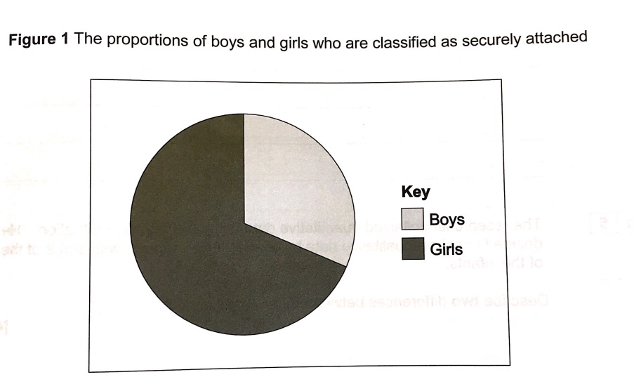
Question: Using the information, estimate the percentage of boys and girls that are securely attached. (2 marks)
Boys=
Girls=
Answer: Boys- 33%, Girls- 67%

NB Notice that a pie chart has been used in this question. You are also required to be able to interpret and analyse the results of a pie chart.

Interpreting mathematical symbols

You will need to be able to understand and use the following mathematical symbols:

Symbol | Meaning | Example
= | equals | 3+1 = 4
< | Less than | 2 < 3
> | Greater than | 3 > 2
≤ | Less than or equal to | 2 ≤ 3
≥ | Greater than or equal to | 3 ≥ 2
<< | Much less than | 0.02 << 3000
>> | Much more than | 3000 >> 0.02
≈ | Approximately equal | 11≈ 10
 | Proportional to | f(x) g(x)

Statistical Testing

One method of analysing data from research is by using statistical inferential tests. The main idea behind these tests is to tell the researcher whether they can accept their experimental hypothesis or not.

The fact that participants spoke more when they drank the energy drink could have been due to chance or a coincidence. To discover if it really is a significant result we have to use inferential statistical tests.

The sign test

To find out if we have found a significant difference we can use the sign test which is used when:-
- We are looking for a difference, rather than an association
- We have used a repeated measures design
- Data is organised into categories (known as nominal data)

Before, we do an example of a sign test and how it is used, it’s important you first understand the concept of probability and critical values.

The concept of probability

All research has a level in order to check for significant differences or relationships.
- The accepted level of probability in psychology is 0.05 (or 5%). This is the level at which the researcher decides to accept their hypothesis or not.
- You will see this written at p< 0.05 (which means, probability of results being due to chance is less than 5%)
- If the experimental hypothesis is accepted, this means there is a less than 5% probability that the results occurs by chance.
- So, this means the researcher can be pretty sure (95% sure) that the difference found was due to their manipulation of the IV.

However, although 5% is a strong benchmark, a researcher may need even more certainty their results were not due to chance. They may therefore choose a stricter significance level like 0.01 (1%). This is usually done in experiments of a socially sensitive nature or there may be a human cost, such as new drugs being tested.

The critical value

When the statistical test has been calculated, the researcher is left with a number, the observed value (what they found) or sometimes called the calculated value.

This needs to be compared with a critical value (sometimes called a table value) to decide whether the result is significant or not.

You find the critical value by using a table of values, but to use the table you need to have the following information:-
- The significance level desired (always 0.05 or 5% except in cases mentioned above)
- The number of participants in the investigation (the N value)
- Whether the hypothesis is directional (one-tailed) or non-directional (two-tailed)

Worked example of the sign test
A food manufacturer wishes to find out if its new breakfast cereal ‘Fizz-Buzz’ will be as popular as its existing product ‘Kiddy-Slop’. No previous research has been done on the preference of these cereal brands.
10 participants try both products and choose which they prefer.
1 participant prefers Kiddy-Slop, 7 prefer the new Fizz-Buzz, and 2 like both equally.

Participant number | Preference | Direction of difference
1 | Fizz-Buzz | +
2 | Fizz-Buzz | +
3 | No difference | Omitted
4 | Kiddy-Slop | -
5 | Fizz-Buzz | +
6 | Fizz-Buzz | +
7 | Fizz-Buzz | +
8 | No difference | Omitted
9 | Fizz-Buzz | +
10 | Fizz-Buzz | +

To calculate the sign test we need to:-

- Insert the data into a table (shown above).
You may be asked to calculate the difference between the scores.

- Use a plus or minus sign to indicate the direction of difference for each participant and note the participants whose scores did not change (this is important because they will not be included when working out N later).

- To calculate the observed value add up the number of times the less frequent sign occurs.
This will give you the value S.
S= 1 in this case.

- Get the critical value of S from a critical value table. This shows the maximum value of S that is significant at a given level of probability.

To do this you need the value of N, the number of participants, leaving out scores with no + or – sign. In this case N=8

You also need to know whether a directional (one-tailed) or non-directional (two-tailed) hypothesis has been used. For this example it is non-directional because no previous research has been conducted into cereal preference.
It is important to get this right because this will affect what the critical value will be.

You also need to know the significance level. This is normally p≤ 0.05 (unless otherwise stated)

Table of critical values

Level of significance for a one-tailed test
 | .05 | .025 | .01 | .005
Level of significance for a two-tailed test
 | .10 | .05 | .02 | .01
N
5 | 0
6 | 0 | 0
7 | 0 | 0 | 0
8 | 1 | 0 | 0 | 0
9 | 1 | 1 | 0 | 0
10 | 1 | 1 | 0 | 0
11 | 2 | 1 | 1 | 0
12 | 2 | 2 | 1 | 1

The calculated value of s must be equal to or less than (≤) the critical value at the 0.05 level of significance

Using the table (important details are circled):

- N=8,
- two-tailed hypothesis,
- significance level p≤ 0.05,
- critical value = 0,
- observed value S=1 (we worked this out earlier by finding the least frequent sign; + or -)

Most importantly you then need to read the information in bold under the critical value table.

This will always be given to you in the exam (you don’t need to learn it).
This information will help you to decide if the results you have are significant or not.

The calculated value of S (in this case S=1) must be equal to or less than the critical value (in this case 0) for it to be significant.

1 is not the same or less than 0, therefore the results are not significant.

How to write this up:

You then need to write these findings up, including all the information you have gathered/calculated to get to this conclusion.

For example, the results of this research are not significant. This is because the observed value of 1 is not equal to or less than the critical value of 0. This is for a two-tailed hypothesis, where N=8 and p≤ 0.05. The researcher must accept the null hypothesis and reject the alternative hypothesis.

There is no significant difference in the preference participants had with breakfast cereals Fizz-Buzz and Kiddy-Slop.

Question two-sign test practice question
A researcher asked participants to rate how happy they felt before and after watching an uplifting film (1=very happy, 8=very sad). Her experimental hypothesis was;
Participants will be significantly happier giving themselves lower ratings after watching an uplifting film than before.

Null-There will be no difference in the happiness ratings of participants, before and after watching an uplifting film.
 | Participant | 1 | 2 | 3 | 4 | 5 | 6 | 7 | 8 | 9
Happiness level (1-8) | Before film | 5 | 4 | 3 | 2 | 7 | 5 | 4 | 4 | 7
 | After film | 6 | 7 | 1 | 8 | 8 | 7 | 6 | 4 | 6
 | Difference in scores | +1 | +3 | -2 | +6 | +1 | +2 | +2 | 0 | -1
 | Sign + or - | + | + | - | + | + | + | +  Remember-It doesn’t matter which you subtract from the other as long as you always subtract in the same direction. | / | -

Show your workings for each question.
1. What is the observed value (S)? Show your calculations. (3 marks)
S= 2
This is because there were 6 + signs, 2 – signs and 1 with no difference.
S= is the less frequent sign that occurs, in this case there were 2 minus signs.
2. What is the critical value (3 marks?)
N= 8 (1 score has been omitted because there was no difference)
P ≤0.05
It is a one-tailed hypothesis
Therefore the critical value is: 1
3. Are the results significant, for p≤0.05? (3 marks)
The calculated value of S (in this case S=2) must be equal to or less than the critical value (in this case 1) for it to be significant.

The results are not significant because the calculated value of 2 is not equal to or less than the critical value of 1. For a one-tailed hypothesis where N=8 and P ≤0.05.

Total 9 marks

Designing a study

In the exam you could be asked to design an experiment, an observation, a content analysis, a questionnaire/interview or a correlational study.
Important Guidance on how to answer these questions:

- Read the question carefully
What are you being asked to design?
Is it an experiment, is it an observation?
Be clear before you start

- Keep your design as simple as possible
You have limited time to complete these questions and the examiners are aware of that.
They do not expect you to design the best experiment ever!
For example, if you are asked to choose a sampling method- pick an easy one e.g. volunteer sampling. Don’t overcomplicate things by picking a stratified sample. It makes your life a lot harder!!

- Be sensible and clear
Only make suggestions that are sensible and could be carried out. You get marks for your study being able to be implemented (carried out).
For example, if you need to measure stress don’t suggest you will take blood samples every 5 minutes and measure the amount of Cortisol in the blood. A much easier suggestion might be to ask participants to rate their stress on a scale of 1-5 (1= not stressed at all, 5=very stressed) every 5 minutes.

- Answer every bullet point
You cannot get into the top band (and therefore achieve the most marks) in these questions unless you address every bullet point they ask you for.
The easiest way to make sure you do this is to use the bullet points as sub titles for each section.
This makes it clear to the examiner that you have answered everything and also makes a structure for you to follow so you cannot miss anything by accident.

- Don’t try to evaluate your own procedure
If they have asked you to choose an experimental design to use and you choose repeated measures. Don’t worry that this design has limitations e.g. order effects.
All of the experimental designs have limitations- a research study will never be perfect!
Just be prepared to justify why you chose that design over independent groups.

- Justify your decisions
Sometimes the question will ask you specifically to justify the design decisions that you make and other questions won’t.
It is good practice to always justify why you have chosen to do something e.g. give the strengths of using that sampling method or experimental design.
These justifications should be specific to the study you are designing. Generic responses are not good enough.
For example, I have chosen to use volunteer sampling because it is an easy method to gather participants. An advert could be placed in a driving magazine to get a sample of people who have an interest in cars.

- Don’t include things you don’t need to
If the question doesn’t ask you to say what sampling method you would use- don’t include it.
The same applies for ethical issues.
Only address what the question asks for otherwise you will waste time writing things that are not going to get you any marks!
Worked example:

The psychologist focused on fluency in spoken communication in her study. Other research has investigated sex differences in non-verbal behaviours such as body language and gestures.
Design an observation study to investigate sex differences in non-verbal behaviour of males and females when they are giving a presentation to an audience.

In your answer you should provide details of:
• the task for the participants
• the behavioural categories to be used and how the data will be recorded
• how reliability of the data collection might be established
• ethical issues to be considered.
[12 marks]

The task for the participants- the mark scheme states this must go beyond just “give a presentation to the audience”
30 participants (15 male, 15 female) would be asked to perform a presentation on the same topic area of “my holiday” this will last for 3 minutes. They will be told that they must not use any props other than notes they take as prompts.
The mark scheme also gives the following suggestions
- presentation of findings from a school project
• presentation on ‘My Hobby’
• presentation on ‘My Holiday’.

The behavioural categories to be used and how the data will be recorded –The Mark scheme states that this must go beyond the idea of global constructs such as ‘body language’ or ‘gesture’. Also detail of recording method to be used, eg record sheet.

An observation schedule will be designed to be used by the observers. There will be clearly operationalised categories that will be clearly explained to observers (see point below). The behavioural categories will be arm movements, smiling, speech hesitations, pointing etc. (all of these are from the mark scheme). An example is seen below. Observers will be asked to make a mark in the correct box every time they see the participant smile or point for instance.
 | smiling | Folded arms | pointing | Arm movements | Head nodding | Touching ear
Male participant 1
Female participant 1

How reliability of the data collection might be established
Using two observers will help to establish reliability because then it means that their responses on the observation schedule above can be compared. By correlating their findings it is possible to establish high reliability if there is a correlation co-efficient of 0.8 or above. Also the observers would be trained beforehand to make sure that they fully understand what they are looking for each behavioural category. A pilot study could also be carried out to check that this training has led to a clear understanding and fully operationalised categories.

Ethical issues to be considered- The mark scheme mentions protection of welfare, confidentiality and deception, respect or integrity. If participants are aware of the behavioural categories beforehand then there may be an element of demand characteristics but participants should be as fully informed as possible and afterwards be fully debriefed and their results shown to them and withdrawn if asked to be. Their identity would be kept anonymous (see observation schedule).

Research methods Exam Questions – there are loads more on psych205.com

Question1
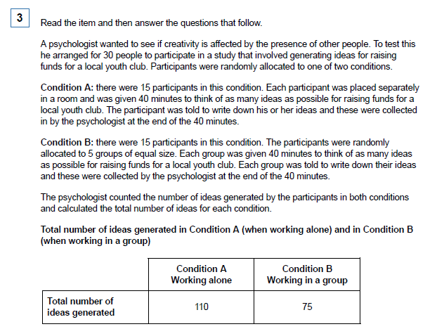

a) Identify the experimental design used in this study and outline one advantage of this experimental design. (3)

(b) Describe one other experimental design that researchers use in psychology. (2)

(c) Apart from using random allocation, suggest one way in which the psychologist might have improved this study by controlling for the effects of extraneous variables. Justify your answer. (2)

(d) Write a suitable hypothesis for this study. (2)

Question 2
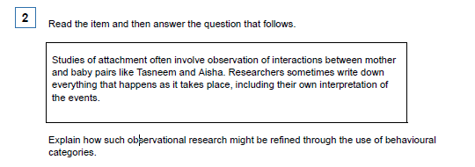

Question 3

A psychologist carried out a research study to investigate the effects of institutional care. To do this, she constructed a questionnaire to use with 100 adults who had spent some time in an institution when they were children.

She also carried out interviews with ten of the adults.

(a) For this study, explain one advantage of collecting information using a questionnaire. (3)

(b) In this study, the psychologist collected some qualitative data. Explain what is meant by
qualitative data. (2)

(c) Write one suitable question that could be used in the interviews to produce qualitative data. (2)

(d) Identify two ethical issues that the psychologist would need to consider in this research.
Explain how the psychologist could deal with one of these issues. (5)

Ethical Issue 1........................................................................................................................................

Ethical Issue 2........................................................................................................................................

(e) Explain how could the psychologist deal with one of these issues? (2 marks)

Question 4
A psychologist studying the primacy effect in impression formation conducted the following experiment.

Each participant was taken to the same room where they listened to a description of a person called ’Alex’. The participants were randomly allocated to one of two groups in the experiment. The psychologist gave each participant the same information about ’Alex’, but the order of the information varied depending on the group.

Group A Five positive points about Alex’s personality were followed by five negative points.

Group B Five negative points about Alex’s personality were followed by five positive points.

After listening to the passage, each participant was asked to state whether they thought ’Alex’ was a friendly person or not. The psychologist recorded how many participants in each group stated that Alex was ’friendly’.

- Identify the type of experiment that was conducted. (1)

- Briefly explain one advantage of the type of experiment that you have identified in your answer to part (a). (2)

- Identify the independent variable and the dependent variable in this experiment. (2)

- Identify the experimental design used in this study. (1) (Total 6 marks)

Question 5
Dave, a middle-aged male researcher, approached an adult in a busy street. He asked the adult for directions to the train station. He repeated this with 29 other adults.

Each of the 30 adults was then approached by a second researcher, called Sam, who showed each of them 10 photographs of different middle-aged men, including a photograph of Dave. Sam asked the 30 adults to choose the photograph of the person who had asked them for directions to the train station.

Sam estimated the age of each of the 30 adults and recorded whether each one had correctly
chosen the photograph of Dave.

(a) Identify one aim of this experiment. (2)

(b) Suggest one reason why the researchers decided to use a field experiment rather than
a laboratory experiment. (2)

(c) Name the sampling technique used in this experiment. Evaluate the choice of this sampling
technique in this experiment. (4)

d) Identify one possible extraneous variable in this experiment. Explain how this extraneous
variable could have affected the results of this experiment. (4)

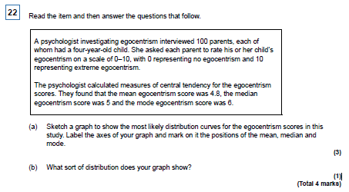
Question 6- data handling and analysis

Question 7
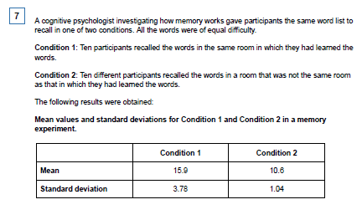

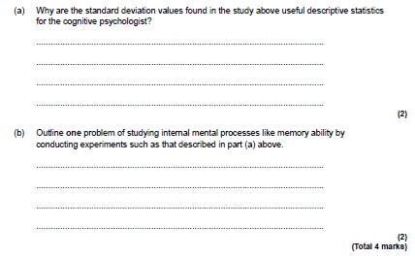

Question 8
